Dissecting the interaction between skill level and mental templates in Late Acheulean handaxe morphology: Archaeological and experimental insights

Cheng Liu[1]

Nada Khreisheh[2]

Dietrich Stout[3]

Justin Pargeter[4]

**Abstract**: Despite the extensive literature focusing on Acheulean handaxes, especially the sources and meaning of their morphological variability, many aspects of this topic remain elusive. Archaeologists cite many factors that contribute to the considerable variation of handaxe morphology, including knapper skill levels and mental templates. Integrating these two lines of literature into a broader theoretical framework of cultural reproduction, here we present results from a multidisciplinary study of Late Acheulean handaxe-making skill acquisition involving thirty naïve participants trained for up to 90 hours in Late Acheulean style handaxe production and three expert knappers. We compare their handaxe to the Late Acheulean handaxe assemblage from Boxgrove, UK. Through the principal component analysis of morphometric data derived from images, our study suggested that knapper skill levels and mental templates have a relatively clear manifestation in different aspects of handaxe morphology. The former relates to cross-sectional thinning (PC1), while the latter refers to handaxe elongation and pointedness (PC2). Moreover, we also evaluated the effects of training on the differential cultural reproduction of these two aspects using the data from a 90-hour-long knapping skill acquisition experiment. We found that the desired shape of a handaxe can be relatively quickly picked up by novices, while reaching the skill level of modern experts requires more training time than was permitted in this extensive and long-running training program.

**Keywords**: Late Acheulean; Handaxe morphology; Boxgrove; Experimental archaeology; Skill level; Mental template; Cultural transmission

# Introduction

The morphological variability of Acheulean handaxes has been one of the most well-studied and well-published topics in paleolithic archaeology (Key & Lycett, 2019; Petraglia & Korisettar, 1998; White, 1998). Despite the recurrent narrative emphasizing the homogeneity and longevity of handaxe assemblages on a global scale and the conservatism behind this phenomenon that evokes genetic explanations (Corbey et al., 2016; Corbey, 2020; Richerson & Boyd, 2005; Sterelny, 2004), many researchers have recognized the diversity within what has been deemed as a unified Acheulean “tradition” and tried to dissect the sources and meaning of this variation (Lycett & Gowlett, 2008; Moncel et al., 2018b, 2018c, 2018a; Nowell, 2002; Nowell & White, 2010; Sharon et al., 2011). More specifically, a complex suite of interconnecting factors (Lycett & Cramon-Taubadel, 2015) have been identified to contribute to handaxe morphological variation, including but not limited to raw material variability (Eren et al., 2014; Lycett et al., 2016; McNabb & Cole, 2015; Sharon, 2008), percussor properties (Shipton et al., 2009), functional differences (Key et al., 2016; Key & Lycett, 2017; Lycett & Gowlett, 2008; Machin et al., 2007; White & Foulds, 2018), reduction method/intensity (Shipton et al., 2009; Shipton & Clarkson, 2015), time budgets (Schillinger et al., 2014b), learning processes (Kempe et al., 2012; Lycett et al., 2016), social signaling (Kohn & Mithen, 1999; Spikins, 2012), aesthetic preferences (Gowlett, 2021; Le Tensorer, 2006), knapper skill levels (Caruana & Herries, 2021; Herzlinger et al., 2017; Stout et al., 2014), and mental templates (García-Medrano et al., 2019; Hutchence & Scott, 2021; Schillinger et al., 2017). From this extensive list, knapper skill levels and mental templates have been repeatedly mentioned and discussed in the now extensive corpus of handaxe studies, and Boxgrove handaxes have been one of the most studied assemblages from these two angles. Of particular attention here are the experimental works conducted by Stout et al. (2014) focusing on inferring knapping skill level and Garcia-Medrano et al. (2019) identifying the mental template of the Boxgrove assemblage. Our paper incorporates these two perspectives into a broader conceptual framework of cultural reproduction and provides novel insights to the same archaeological assemblage by comparing it with experimentally made handaxes.

## Mental template

In its classical definition, the term mental template indicates that the “idea of the proper form of an object exists in the mind of the maker, and when this idea is expressed in tangible form in raw material, an artifact results” (Deetz, 1967: 45). This concept lies at the very foundation of the cultural-historical approach in that the identification of archaeological cultures is based on the existence of distinct mental templates in a given spatial-temporal framework. Early researchers, whether explicitly or implicitly, often endorsed this conceptual framework and actively applied it in the typological analysis of handaxes at the regional level (Roe, 1969; Wenban-Smith et al., 2000; Wenban-Smith, 2004). Combined with the production of large flakes, the emergence of mental templates (or “imposed form”) has been recognized as a major technological innovation of the Acheulean compared with the Oldowan (Isaac, 1986). For a decade or so, this concept has been less frequently used, since it was criticized for a) its normative and static assumption (Lyman & O’Brien, 2004), b) ignoring other competing factors such as raw material constraints (White, 1995), and c) being constrained by the basic fracture mechanics and design space of bifacial technology (Moore, 2011; Moore & Perston, 2016). To avoid the historical baggage associated with this controversial term, some researchers developed alternative frameworks such as “design imperatives” derived from utilitarian and ergonomic principles, which refers to a set of minimum features shared by all handaxes including their glob-butt, forward extension, support for the working edge, lateral extension, thickness adjustment, and skewness (Gowlett, 2006; Wynn & Gowlett, 2018). The major difference between the concepts of design imperatives and mental templates lies in the fact that the former does not necessarily require the presence of explicit internal representations of form, where the shape of handaxes can instead emerge “through the coalescence of ergonomic needs in the manipulation of large cutting tools (Wynn, 2021: 185).”

Recently, researchers have actively addressed the above-mentioned critiques and reconceptualized the concept of mental template in the study of handaxe morphology. Regarding the normative and static assumptions, Hutchence and Scott (2021), for example, leveraged the theory of “community of practice” (Wenger, 1998) to explain the stability of Boxgrove handaxe design across multiple generations. From this perspective, social norms behind the consolidated material expressions were developed and negotiated by individuals in a group who have a shared history of learning. They further emphasized that emergent actions of individual knappers also contribute greatly to the shape of Boxgrove handaxes but they were simultaneously constrained by the imposition of social norms. This view also somewhat echoes the “individualized memic construct” proposed by McNabb et al. (2004), which highlighted the influence of individual agency that is complementary to the traditionally favored explanation of social learning. As for the critique towards confounding factors explaining morphological variability, raw material is often treated as an important variable to be controlled at the very beginning of a research design focusing on mental templates. This is best exemplified by an experimental study of García-Medrano et al. (2019), where they carefully chose experimental nodules mirroring those found in the Boxgrove archaeological assemblage in composition, size, and shape. Regarding the critique of design space constraint, Moore and Perston’s experiment (2016) suggested that bifaces can be manufactured through flake removals dictated by a random algorithm. However, Moore (2020: 656-657) also suggested that these random experiments cannot produce “attributes like the congruent symmetries of handaxes seen in the Late Acheulean.” In short, when exercised with proper caution, the concept of mental templates still has its value in our study of handaxe morphological variation, which can be further dissected into a series of shape variables corresponding to pointedness, elongation, and cross-sectional thinning among other things.

## Skill level

Following the reconceptualization of the mental template as a more flexible and interactive concept, one possible way of defining skill is the capacity for a knapper to realize mental templates using the resources available (Roux et al., 1995: 66). This version of conceptualization, particularly relevant when it comes to motor skills such as knapping, can be dismantled into two mutually dependent aspects, namely the intentional aspect (goal/strategic planning) and the operational aspect (means/motor execution) (Connolly & Dalgleish, 1989). It also roughly corresponds to the well-known dichotomy developed by French lithic analysts of “*connaissance*” (abstract knowledge) and “*savoir-faire*” (practical know-how) (Pelegrin, 1993). As Stout (2002: 694) noted, the acquisition of skill is deeply rooted in its social context, and it is not composed of “some rigid motor formula” but “how to act in order to solve a problem”. This ecological notion of skill somewhat mirrors Hutchence and Scott’s (2021) reconceptualization of the mental template in that they both refute the idea that technology is simply an internal program expressed by the mind and they prefer a dynamic approach emphasizing the interaction between perception and action. The manifestations of skill in materialized form display a great amount of variation, but ethnoarchaeological studies have repeatedly suggested that skills can be improved through practice as perceived by local practitioners. It is thus possible to evaluate the skill levels reflected in knapping products (Roux et al., 1995; Stout, 2002). When contextual information is less readily available as in the Late Acheulean archaeological assemblages, how to properly operationalize and measure knapping skills has been a methodological issue receiving much attention among archaeologists (Bamforth & Finlay, 2008; Kolhatkar, 2022). In addition to measurements that can be almost applied in any lithic technological system such as raw materials, platform preparation, as well as hinges, in the context of handaxe technology, symmetry (Hodgson, 2015; Hutchence & Debackere, 2019) and cross-sectional thinning (Caruana, 2020; Pargeter et al., 2019; Stout et al., 2014; Whittaker, 2004: 180-182) have been frequently quoted as reliable and distinctive indicators of the skill level as supported by several experimental studies. These two features have also been commonly used as standards for dividing Early Acheulean and Late Acheulean (Callahan, 1979; Clark, 2001; Schick & Toth, 1993).

## Cultural reproduction

The cultural reproduction, or cultural transmission as described in standard cultural evolutionary literature (Eerkens & Lipo, 2005, 2007), of mental templates and skill levels makes them reach beyond individual-level practice and form a repetitive pattern that can be identified in archaeological records. Nonetheless, the abstract shape of handaxe as a mental template that is often pulled away from its original substrate has been frequently treated as the main research subject of cultural transmission experiments (Schillinger et al., 2014b, 2017, 2015), while how knapping skill as another source of variation is reproduced during the learning process and how it moderates the material manifestation of mental templates has been rarely discussed. The ignorance of the latter becomes one of motivations behind our terminological choice of “reproduction” over “transmission”, where the former implies more than just the copying of an static image with information loss (Liu & Stout, 2022; Stout, 2021). This reframing essentially echoes the stance of extended evolutionary synthesis (EES) on inclusive inheritance that phenotypes are not inherited but reconstructed in development (Laland et al., 2015: 5), which has also received more attention recently in the domain of cultural evolution (Charbonneau & Strachan, 2022; Strachan et al., 2021).

Centering around the concept of cultural reproduction, we aim to explore the possibility of dissecting the interaction of skill level and mental template through a comparative study of an archaeological handaxe assemblage known for its remarkable high skill level, a reference handaxe collection produced by modern knapping experts, and an experimental handaxe sample produced by modern novice knappers. We generated the novice handaxe collection from a 90-hour skill acquisition experiment providing the opportunity to introduce the diachronic dimension of training time and interrogate its impact on the variables of interest. As such, we propose the following two interconnected research questions in this article: 1) Can skill level and mental templates be efficiently detected from handaxe morphometric data? Accordingly, we predict that the morphometric variables showing overlap between Boxgrove and expert samples while being markedly different from novice samples reflect skill level differences, and all three group should show a similar mental template since this is a common target. 2) Does training has a differential effect in terms of the reproduction of skill level and mental templates among novices? Our hypothesis is that throughout the training the novice samples should become more similar to expert samples in both skill level and mental template, but the acquisition of the former aspect will be more challenging and thereby slower than the latter aspect. This hypothesis is informed by the previous study of Pargeter et al. (2020) showing that in handaxe manufacture novices’ predictions of the contour of flakes to be removed are highly similar to those of expert knappers, while novices do not have the right forces and accuracy to successfully remove their target flakes to produce a nice handaxe.

# Materials and methods

## Boxgrove handaxe collection

The archaeological site of Boxgrove is located in the former Eartham quarry, Boxgrove, West Sussex, featuring a long sequence of Middle Pleistocene deposits (Pope et al., 2020; Roberts & Parfitt, 1998). This 500-ka-old site has documented exceedingly rich details of Lower Paleolithic hominin subsistence behaviors (Smith, 2013, 2012) and their paleoenvironmental contexts (Holmes et al., 2010; Preece & Parfitt, 2022). In addition to the presence of one of the earliest hominin fossil (tentatively assigned to *Homo heidelbergensis*, Hillson et al., 2010; Lockey et al., 2022; Roberts et al., 1994) and bone assemblages with anthropogenic modifications in northern Europe (Bello et al., 2009), Boxgrove is mostly known for its large sample size of Late Acheulean-style flint handaxes and the high skill level reflected in their manufacture (**Figure** @ref(fig:photos)). As such, it has received wide research attention in the past two decades regarding the relationships between technology, cognition, and skills (García-Medrano et al., 2019; Iovita et al., 2017; Iovita & McPherron, 2011; Key, 2019; Shipton & Clarkson, 2015; Stout et al., 2014). To identify the morphological manifestation of knappers’ skill level in our study, we selected a complete handaxe assemblage (n=326) previously analyzed and reported in digital formats by Iovita and McPherron (2011), which is currently curated at the Franks House of the British Museum (Iovita et al., 2017). The digital photographs are taken of each handaxe at a 90 $​^{∘}$ angle, which was oriented with the tip to the right of the photos, and the camera faces the most convex surface of the handaxe (Iovita & McPherron, 2011).

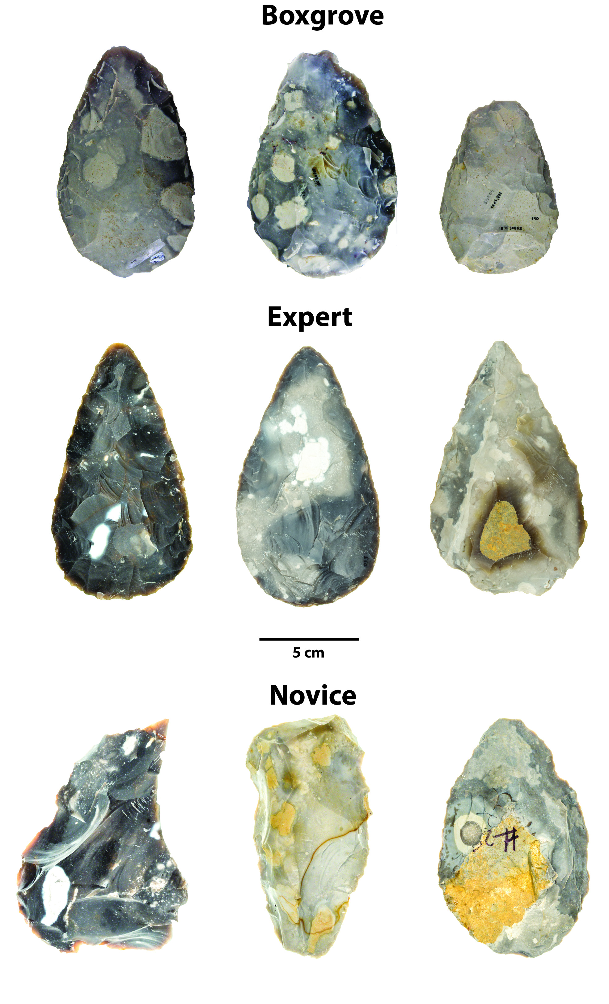

A selection of Boxgrove handaxes and modern replicas produced by experts and novices.

## Experimental handaxe collection

The handaxe experimental replicas used in this study comprised two sub-collection (**Figure** @ref(fig:photos)). The first sub-collection includes 10 handaxes knapped by three expert knappers, including Bruce Bradley (n=4), John Lord (n=3), and Dietrich Stout (n=3) (Stout et al., 2014). These handaxes were made for previous research projects, which similarly aimed to approximate ‘Late Acheulean’ handaxes explicitly comparable to the Boxgrove assemblage (Faisal et al., 2010; Stout et al., 2014; Stout et al., 2011). The second sub-collection is produced from a 90-hour handaxe knapping skill acquisition experiment (Bayani et al., 2021; Pargeter et al., 2020; Pargeter et al., 2019), where 30 adults with no previous experience in knapping were recruited from Emory University and its surrounding communities and requested to make 132 handaxes in total. Among these 30 adult participants, 17 have gone through multiple one-to-one or group training sessions that amounted to 89 hours in maximum, while the remaining 13 were assigned to the controlled group, where no formal training is given. As part of the preparation efforts, the experimental team spalled the Norfolk flints acquired through [Neolithics.com](https://neolithics.com/) into flat blanks of similar size and shape for training and assessments. The mechanical properties of these raw materials are comparable to the ones used in Boxgrove in that they are both fine-grained and highly predictable in fracturing process.

In the knapping skill acquisition experiment, all research participants participated in the initial assessment (assessment 1 in our data set) before formal training, where they each produced a handaxe after watching three 15-minute videos of Late Acheulean style handaxes demonstrated by expert knappers and examining four Late Acheulean style handaxe replicas from our expert sample. Training was provided by verbal instruction and support from the second author, an experienced knapping instructor (Khreisheh et al., 2013) with 10 years knapping practice and specific knowledge of Late Acheulean technology including the Boxgrove handaxe assemblage. She was present at all training sessions to provide help and instruction to participants. All training occurred under controlled conditions at the outdoor knapping area of Emory’s Paleolithic Technology Lab, with knapping tools and raw materials provided. All participants were instructed in basic knapping techniques including how to select appropriate percussors, initiate flaking on a nodule, maintain the correct flaking gestures and angles, prepare flake platforms, visualize outcomes, deal with raw material imperfections, and correct mistakes. Handaxe-specific instruction included establishment and maintenance of a bifacial plane, cross-sectional thinning, and overall shaping. The training emphasized both aspects of handaxe making technical skill (the importance of producing thin pieces with centered edges) as well as mental template related markers (symmetrical edges).

Subsequently, the 17 participants in the experimental group were assessed after every ten hours of the cumulative learning period, where each of them was requested to produce a handaxe for expert knapper’s (N. Khreisheh) review, leading to the compilation of a data set composing 9 assessments in total. It should be also noted that 6 out of 17 participants dropped out of the research before the final assessment due to personal reasons. To detect the effect of training on skill level and mental template, we reorganized our assessment classification scheme and combined it into three broader categories, namely pre-training (assessment 1), early training (assessment 2-5), and late training (assessment 6-9), which helps increase the sample size of the measured intervals. A more detailed experimental protocol can be assessed in one of our published papers (Pargeter et al., 2019).

## Lithic analysis

To better understand the morphological variation of Boxgrove handaxe collection, we adopted a standardized analytical procedure to extract the morphometric information from 752 photos of the studied samples (Iovita & McPherron, 2011), which include both the front and lateral views of a given specimen. First, we used Adobe Photoshop to conduct a batch transformation of the samples’ pixel scale into a real-world measurement scale based on the fixed photographic setting. This is then followed by the batch conversion of color photographs to a black-and-white binary format. Subsequently, we cropped the silhouettes of handaxes one by one using the Quick Selection Tool in Adobe Photoshop. The metric measurements were conducted in ImageJ (Rueden et al., 2017), where we employed a custom ImageJ script (Pargeter et al., 2019) to measure the maximum length, width, and thickness of a given silhouette. The width and thickness measurements are taken at 10% increments of length starting at the tip of each handaxe (**Figure** @ref(fig:ImageJ)), which eventually leads to 19 morphometric variables in total (1 length measurement, 9 width measurements, and 9 thickness measurements). Finally, we calculated the geometric means of all 19 linear measurements to create a scale-free data set that preserves the individual morphological variation at the same time (Lycett et al., 2006). This allometric scaling procedure controls for size variation which may come from initial blanks and/or reduction intensity (shaping/resharpening). Notably, Shipton and Clarkson (2015) previously found that reduction intensity does not have a strong impact on the shape of handaxes. The same procedure was also applied to the morphometric analyses of the experimental handaxe collection, which was partially published in Pargeter et al. (2019).

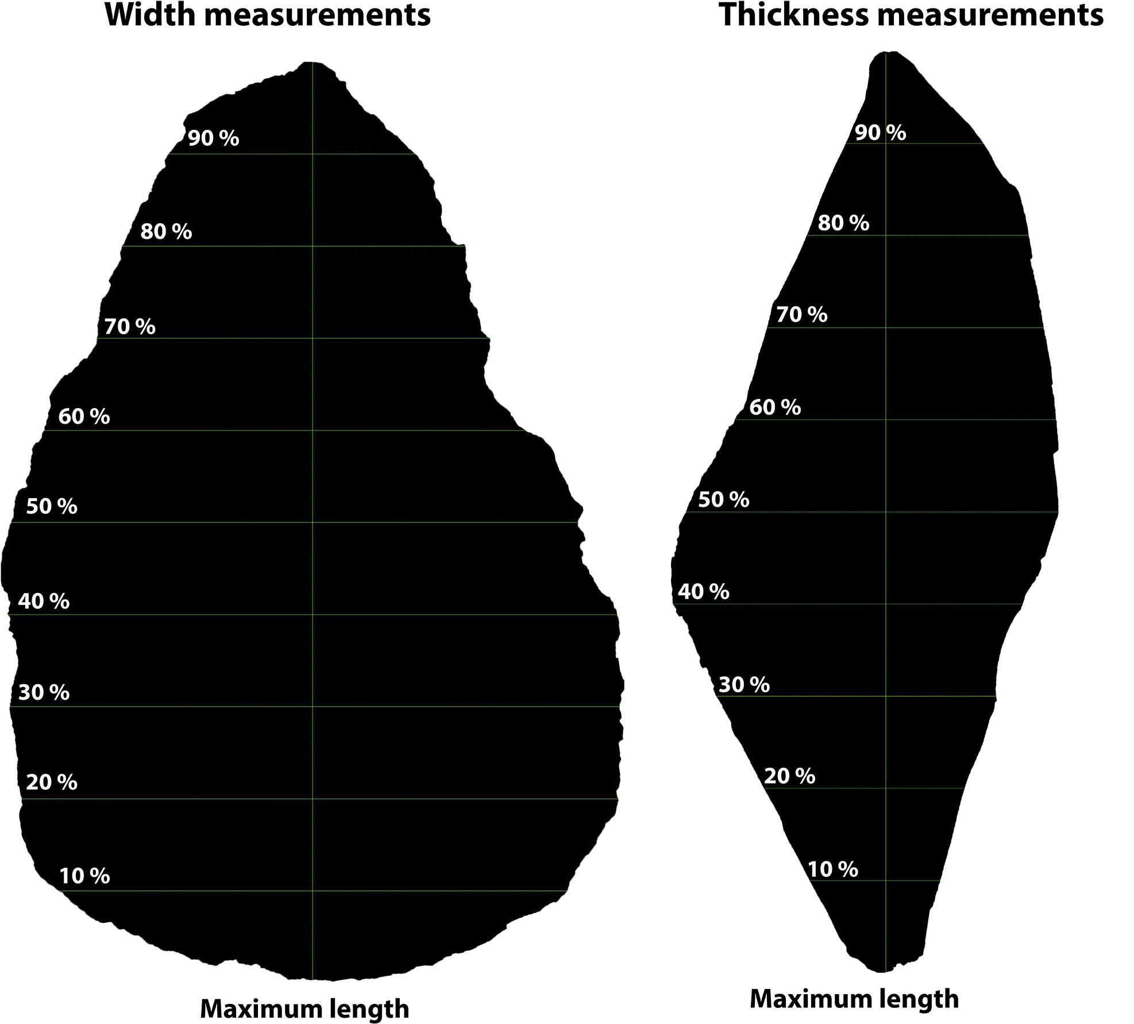

A visual demonstration of the handaxe measurement protocol using Image J (after Pargeter et al. 2019: Figure 5).

## Statistical analyses

We use the statistical programming language R 4.1.1 (R Core Team, 2021) to conduct statistical analyses and data visualization in this study, particularly the R packages “FactoMineR” (Lê et al., 2008) and “ggstatsplot” (Patil, 2021). As the initial step, simple visualization techniques such scatter plots are frequently used to explore the relationships between variables of interest. Given the number of variables involved in this study, we used principal component analysis (PCA) to reduce the dimension and identify the possible patterns in this morphometric data set, which is one of the most used techniques in similar studies (García-Medrano, Maldonado-Garrido, et al., 2020; García-Medrano, Ashton, et al., 2020; Herzlinger et al., 2017; Iovita & McPherron, 2011; Shipton & Clarkson, 2015; Stout et al., 2014). To detect the effect of training on novices’ performance as compared with archaeological samples and handaxe made by experts, we also compare the corresponding metrics built on PCA across different training periods and across all groups using the Games-Howell nonparametric post-hoc test. Compared with other nonparametric tests frequently used in archaeological research for multiple group comparison such as Tukey’s test, Games-Howell test does not rely on the assumptions of sample normality, and equal sample sizes and equal variance are not necessary conditions to perform this test. The sample size of each compared group can be as low as 6 (Games & Howell, 1976; Sauder & DeMars, 2019). Lastly, we compare the delta weight, as defined by the difference between initial nodule weight and end product weight, between these groups to understand the effect of reduction intensity on morphological variation. This study adheres to the principles of reproducibility and data transparency of archaeological research by depositing all the codes and data sets involved in an open-access online repository (Marwick, 2017), which are available as supplementary materials and can be accessed through the author’s Github (<https://github.com/Raylc/Boxgrove-Exp>).

# Results

## Principal component analysis

Our analysis suggested that the first two components already explain 77.2% of the variation for the entire morphometric data set composed of 19 variables (**Figure** @ref(fig:Screeplot)), which is a rather reasonable variance ratio to avoid overfitting. Variable loadings (**Table** @ref(tab:tab1)) indicate that the first principal component (PC1) captures relative cross-sectional thickness (“refinement”). It is positively correlated with all thickness measurements while negatively correlated with all other measurements. A higher PC1 value thus indicates a handaxe that is thicker relative to width and length, and vice versa. The second principal component (PC2) tracks elongation and pointedness, as indicated by a positive covariance of maximum length and bottom width/thickness. As PC2 increases, a handaxe will be relatively longer and more convergent from the broad base to the tip. Thus, PC1 corresponds to cross-sectional thinning and PC2 to a narrowing of the tip relative to length and base dimensions.

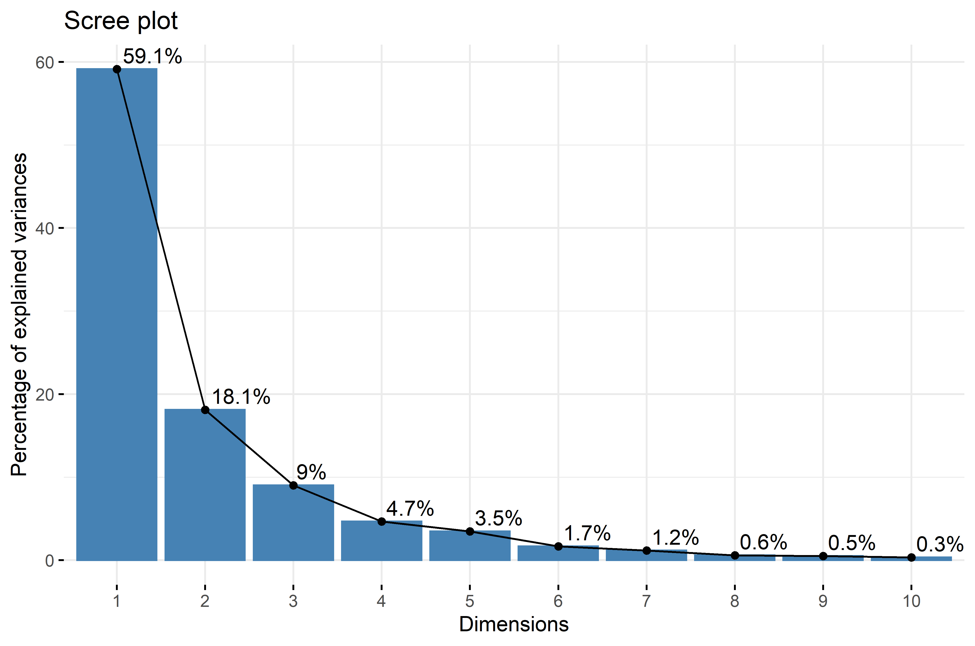

A scree plot showing the percentage of explained variances of the first 10 principal components.

Variable loadings for the first two principal components. PC1 (Dim.1) is postively correlated with all thickness-related variables and negatively correlated with all width-related variables and the maximum length. PC2 (Dim.2) is positively with bottom width and thickness variables as well as the miximum length and negatively correlated with width and thickness variables of the tip area.

A closer look at the principal component scatter plot (**Figure** @ref(fig:GeneralPCA1)) yields the clustering of different groups of handaxes. The majority of Boxgrove handaxes occupy an area featuring negative values of both PC1 and PC2. The expert group is similar to the Boxgrove group in PC1, while the former has a relatively higher PC2 value than the latter on average. The group of novice displays the highest ranges in both PC1 and PC2 values according to the scatter plot, however, it is rather pronounced that most handaxes made by novices have a positive PC1 value that is different from both the groups of Boxgrove and experts.

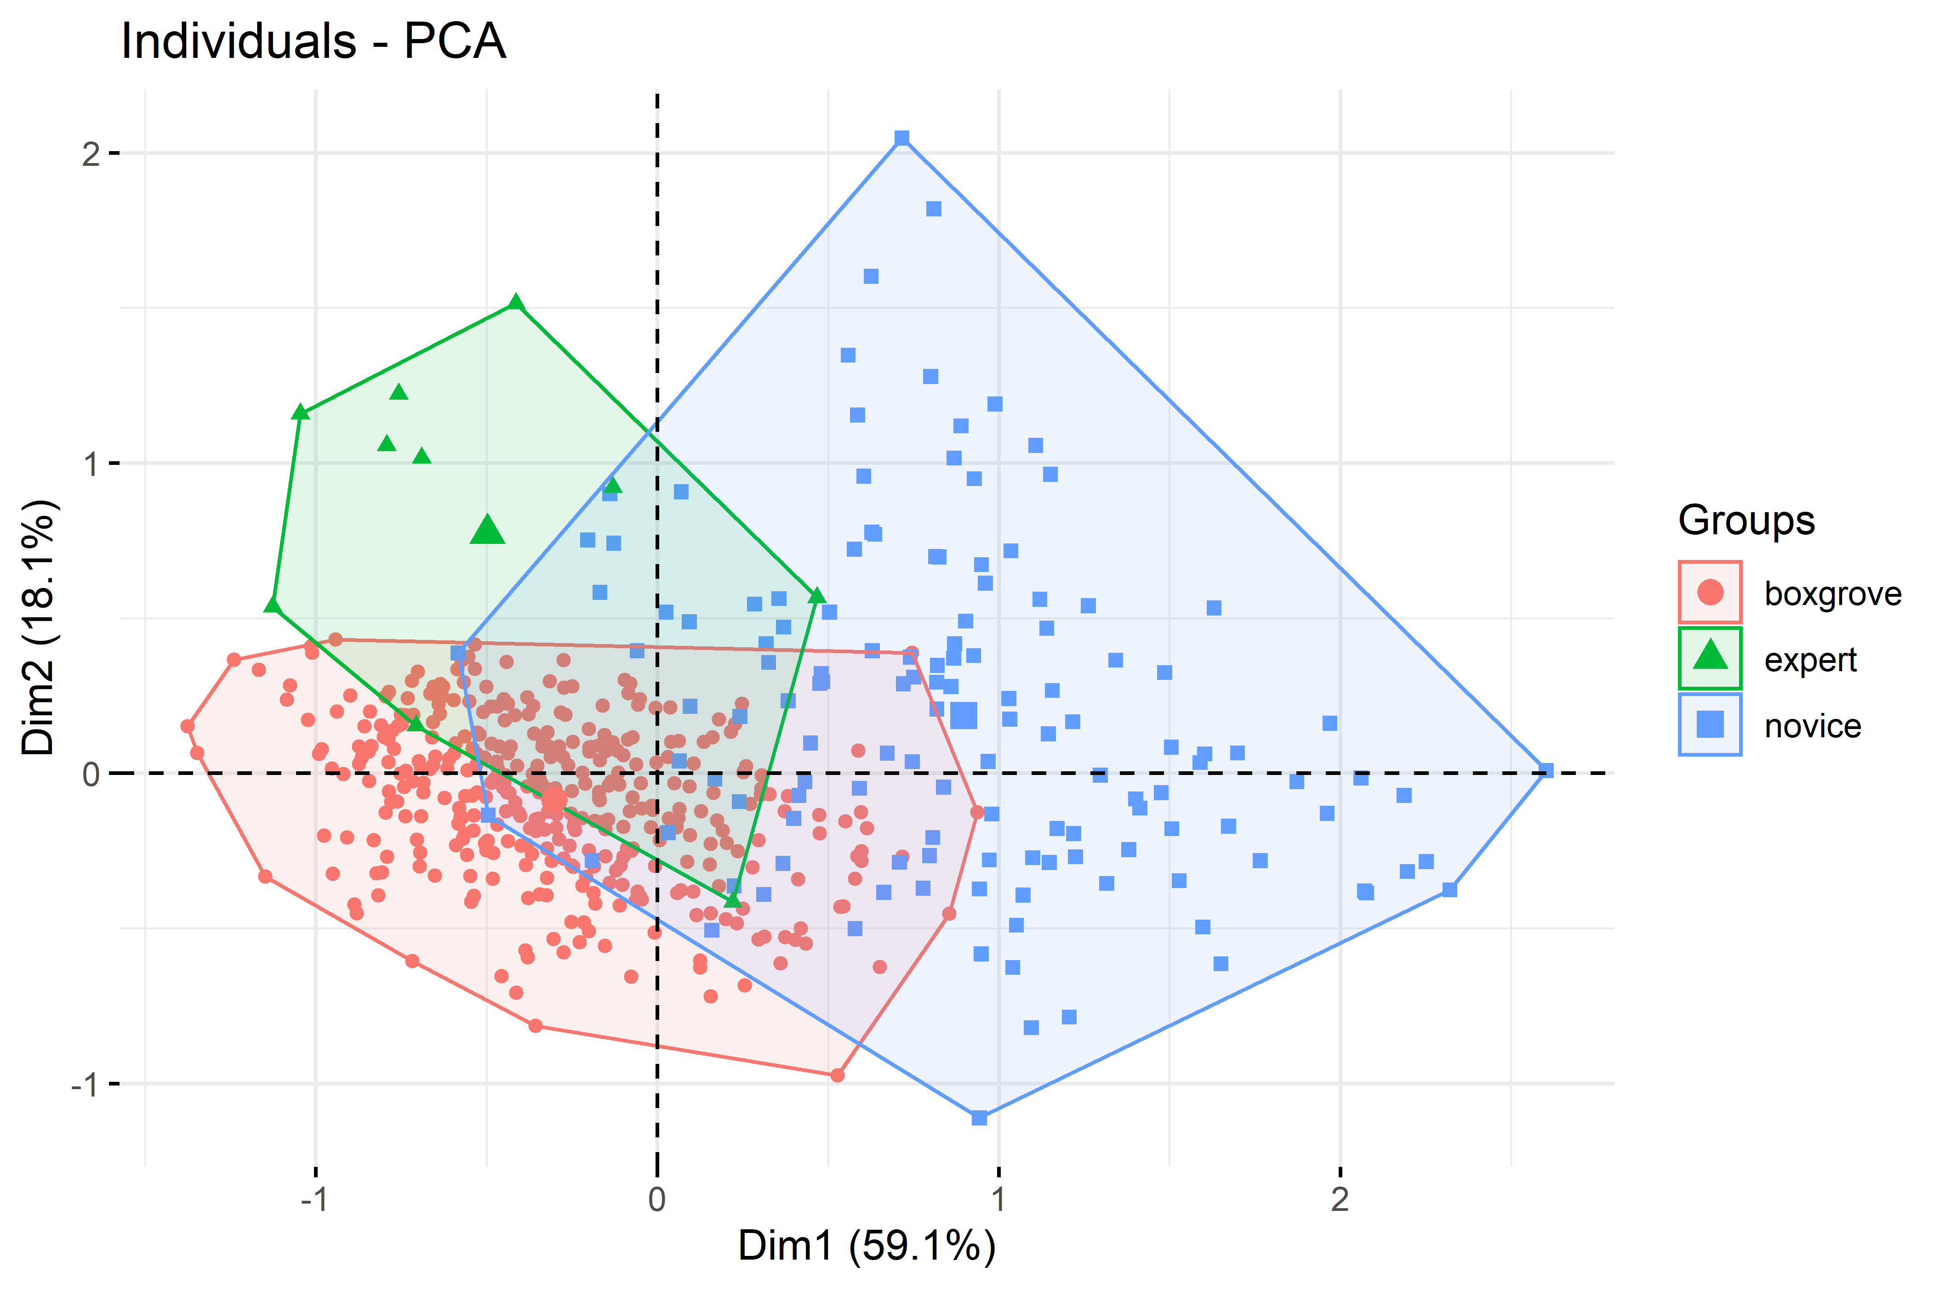

A principal component scatter plot of handaxes from the groups of Boxgrove (red, n=326), expert (green, n=10), and novice (blue, n=132).

In addition, visual inspection of the principle component scatter plot (**Figure** @ref(fig:GeneralPCA1)) suggested that PC1 and PC2 might be negatively correlated within the Boxgrove and Expert groups. To test this, we conducted a series of exploratory plotting and statistical analyses of the PC values of three groups analyzed in our analysis (**Figure** @ref(fig:PCcorrelation)). Across all three groups, a negative correlation has been displayed between the PC1 and PC2 values, although this trend is not statistically significant (r=-0.41, p= 0.24) in the expert group, probably because of its small sample size.



A scatter plot showing the correlation between PC1 and PC2 respectively in the groups of Boxgrove (left, n=326), expert (middle, n=10), and novice (right, n=132). The upper left area in each individual plot displays statistical reporting from a frequentist perspective, including the student-t test statistics, p-value, Pearson correlation coefficient, confidence interval, and sample size. The lower right area in each individual plot displays statistical reporting from a Bayesian perspective, including the natural logarithm of Bayes factor, posterior type and estimate, credible interval, and prior type and value.

## Effects of training

We extracted the PC1 and PC2 values of individual handaxes and compared them between different groups, where the novice group was divided into three sub-groups based on their training stages as specified in the method section. As such, we found that for PC1 values (**Figure** @ref(fig:PCA1)), the only two group comparisons that are **not** statistically significant are the one between Boxgrove and Expert ($t=-1.65$, $p>0.05$) and the one between Early training and Late training stages ($t=-0.649$, $p>0.05$), which at least partially confirms our visual observation of the general PCA scatter plot. Likewise, for PC2 values (**Figure** @ref(fig:PCA2)), the group comparison between the Early training and Late stages again is not statistically significant ($t=0.333$, $p>0.05$). An unexpected result is that the mean PC2 value difference between the Pre-training group and Boxgrove is also not statistically significant ($t=-0.818$, $p>0.05$). These results essentially suggest that there is a significant difference between the pre-training group and post-training groups in both PC1 (thinning) and PC2 (pointedness). However, the effects of training across different assessment periods on both dimensions are not significant. Regarding the delta weight of different groups, our analysis (**Figure** @ref(fig:weight)) suggests that there is a significant difference between the pre-training group and Late training group, while all other pairwise group comparison results are insignificant. It can also be inferred that the expert group display a higher variability in terms of delta weight compared with novices.

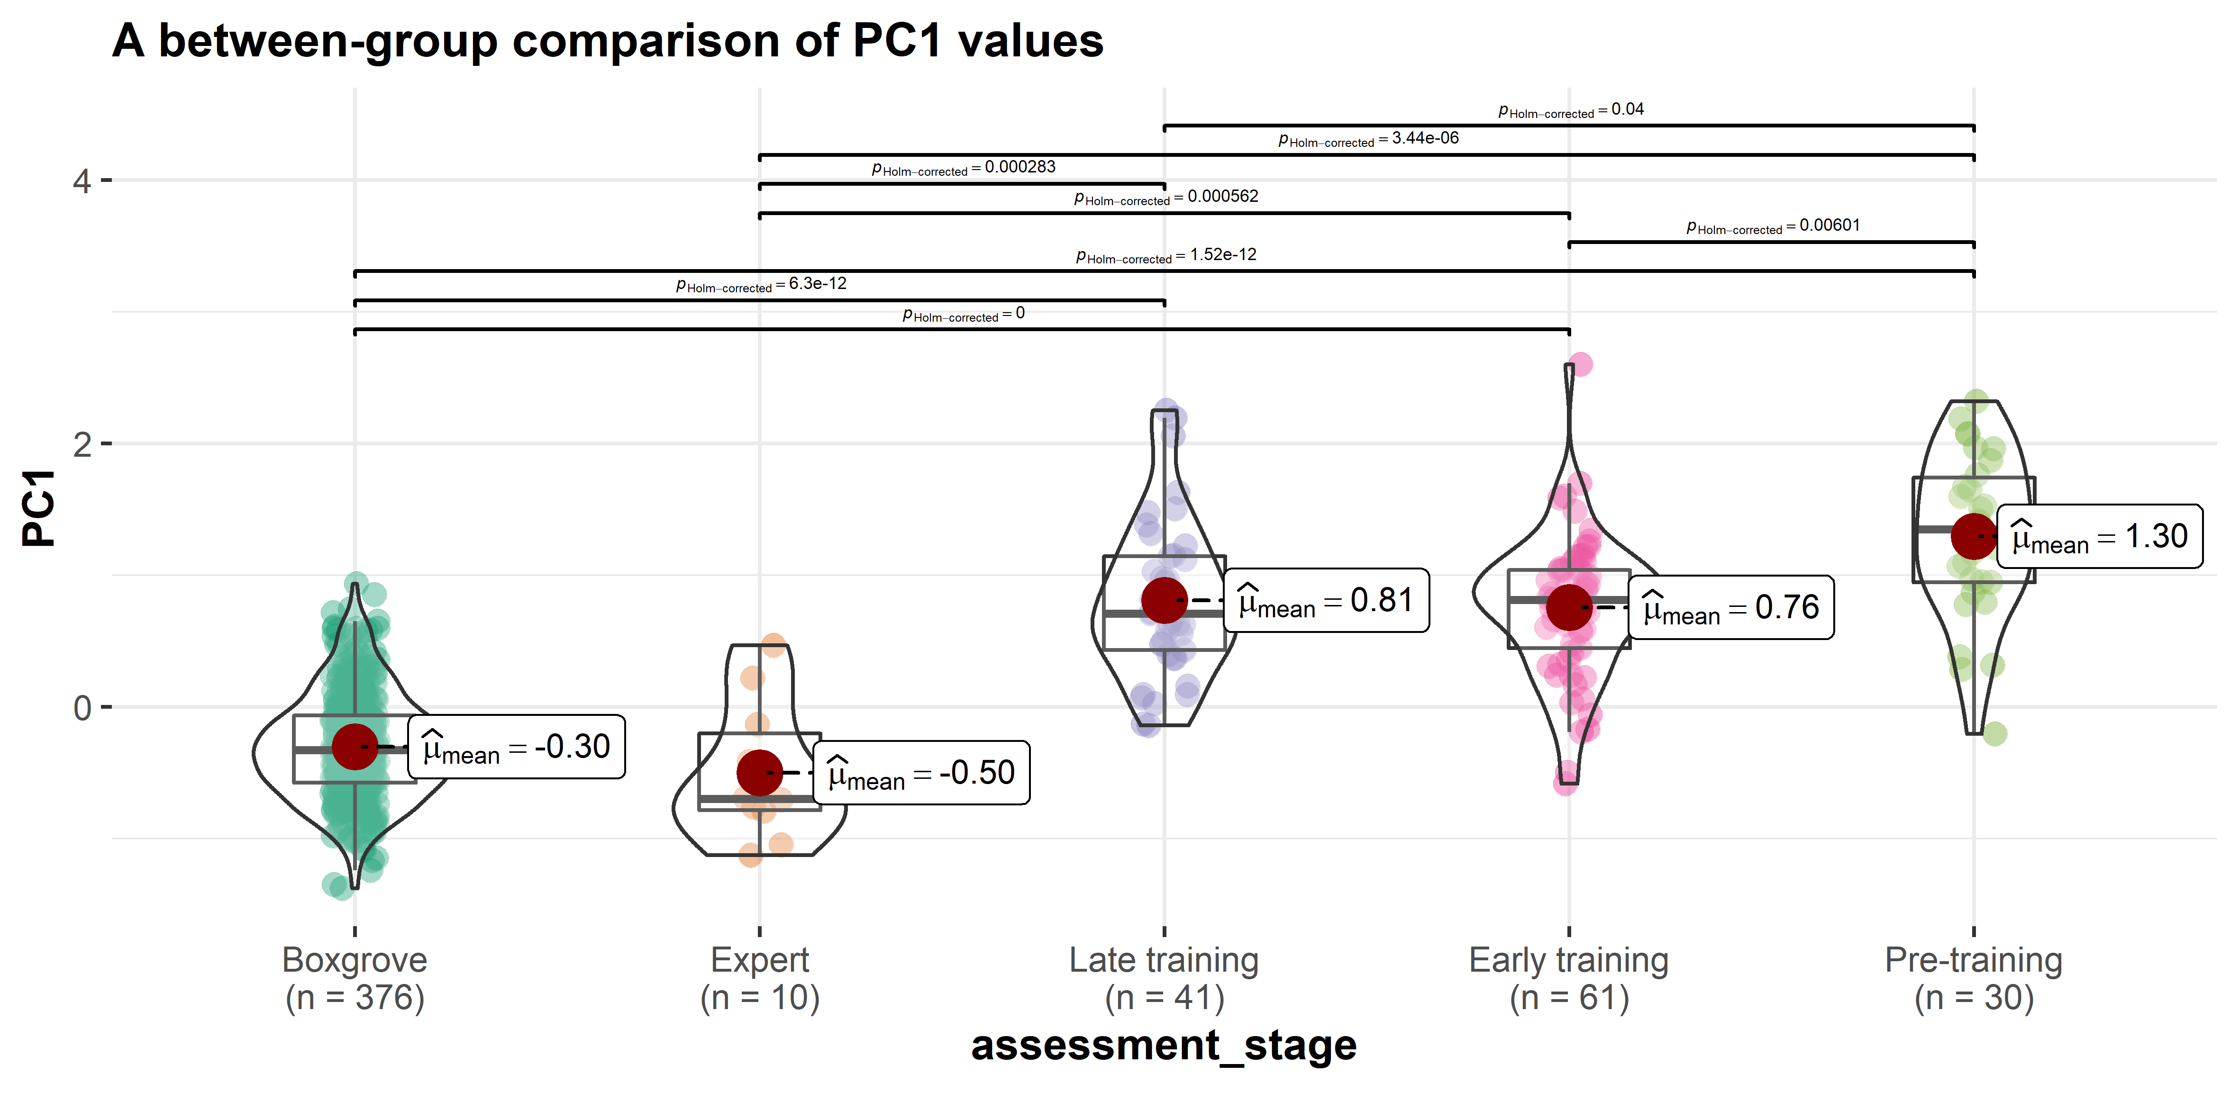

A between-group comparison of PC1 values.

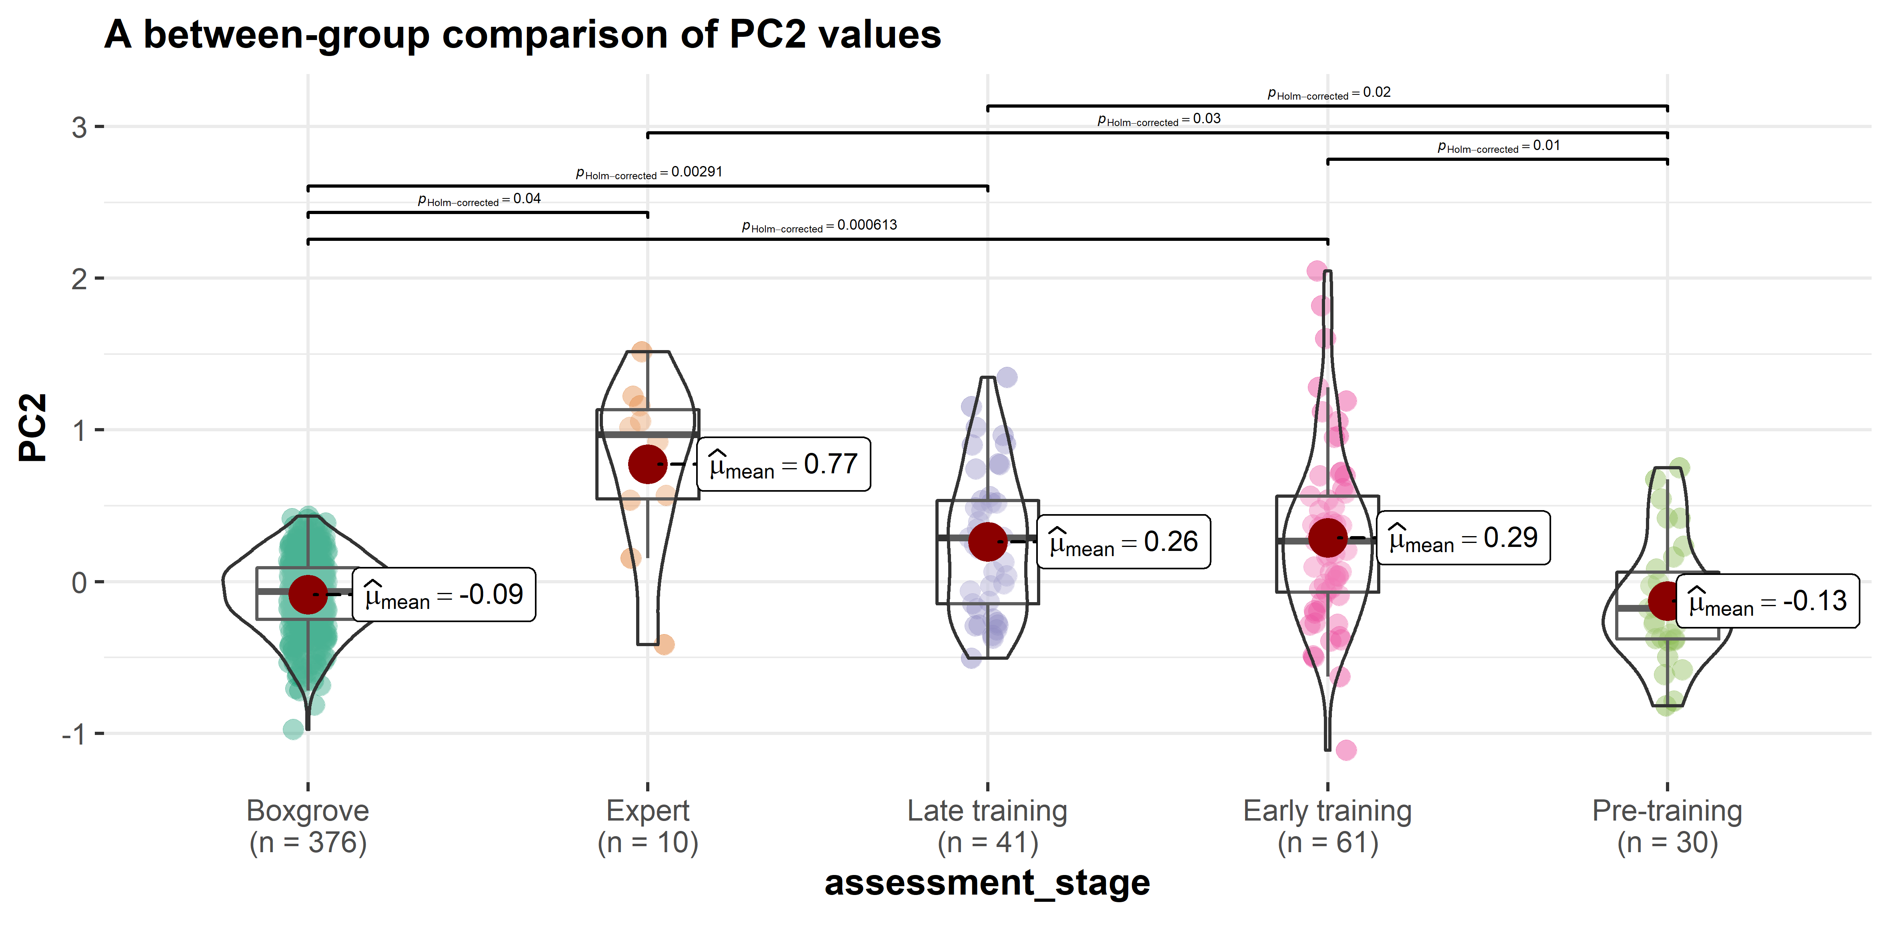

A between-group comparison of PC2 values.

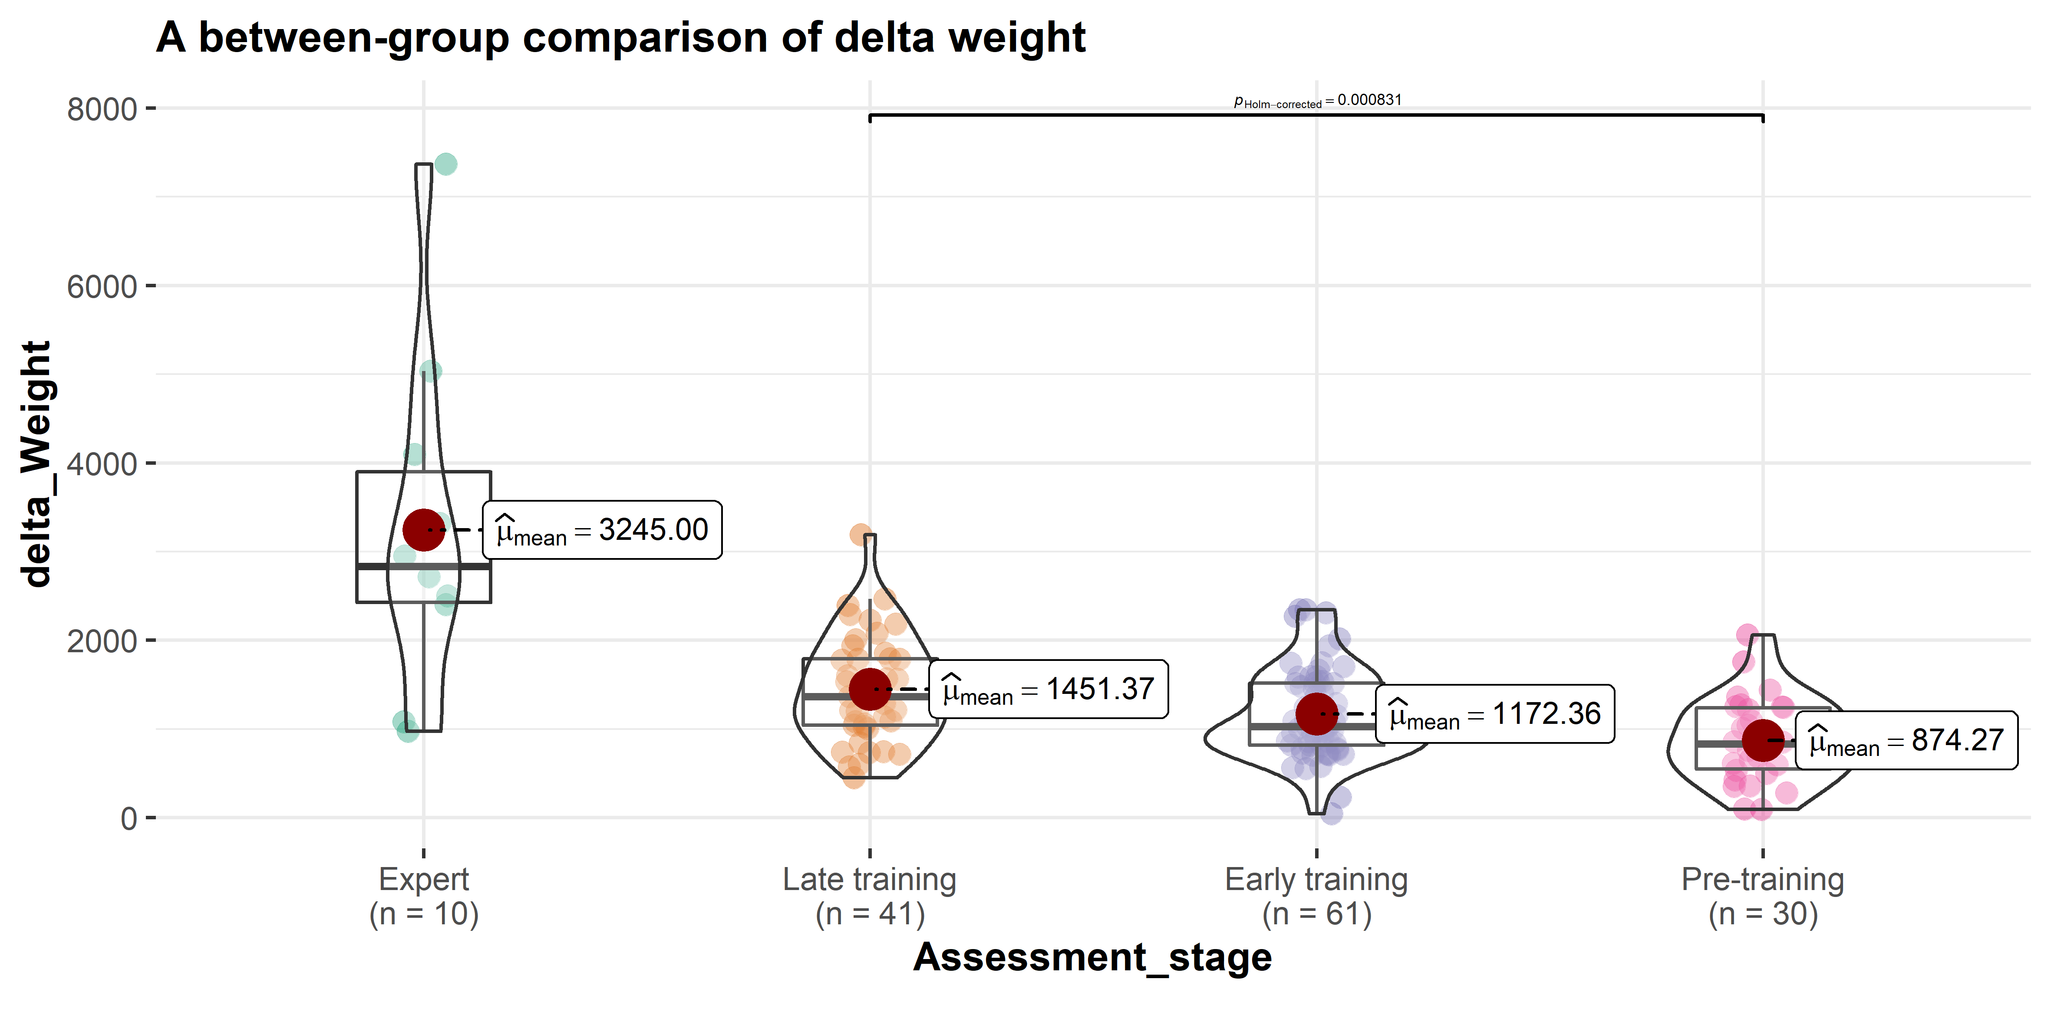

A comparison of the delta weight between the pre-training, early training, late training, and the expert group.

# Discussion

Our study suggests that both skill level and mental template have a relatively clear manifestation in different aspects of handaxe morphology, where the former is related to cross-sectional thinning (PC1) while the latter relates to handaxe elongation and pointedness (PC2). Moreover, we also evaluated the differential effects of training using the data from a 90-hour long knapping skill acquisition experiment and confirmed the previous finding (2019) that reaching the skill level of modern experts requires more training time than was permitted in this extensive and long-running training program. In accordance with the existing literature on handaxe knapping skill (Callahan, 1979; Caruana, 2020; Stout et al., 2014), the results of PCA suggested that PC1 (cross-sectional thinning) is a robust indicator of skill level as it is a common feature shared by modern expert knapper and Boxgrove knappers. Thinning is regarded as a technique requiring a high knapping skill level because it requires one to carefully detach flakes in an invasive manner while not breaking the handaxe into several pieces, serving the purpose of achieving the desired convexity and/or volume. This procedure involves precise control of striking forces, strategic choice of platform external angle, and attentive preparation of bifacial intersection plane, all of which were part of our experimental training program (Callahan, 1979; Caruana, 2022; Pargeter et al., 2020; Shipton et al., 2013; Stout et al., 2014). Experimental studies have also shown that the thinning stage of handaxe produce often involves the use of soft hammers, which is also supported by indirect archaeological evidence of flake attributes from Boxgrove (Roberts & Parfitt, 1998: 384-394; Roberts & Pope, 2009), although the validity of differentiating purcussor types (hard hammerstone, soft hammerstone, and antler hammer) based on flake attributes has been challenged by other experimental studies(Driscoll & García-Rojas, 2014). It should be noted that both our experts and novices frequently used soft hammers in the production of experimental assemblages. In the skill acquisition experiments, novice knappers were explicitly taught to switch to the soft hammer for thinning purposes, but some of them did not follow the instruction during the assessment. On the other hand, it has also been shown that hard hammers can also be used to achieve similar thinning results (Bradley & Sampson, 1986; Pelcin, 1997), and the replicas produced by Bruce Bradley in our expert reference collection did not involve the use of soft hammers.

Given the dissimilarity of PC2 (elongation and pointedness) values between archaeological and experimental samples and its similarity among modern knappers, we argue that this dimension reflects different mental templates, where the Boxgrove assemblage displays an ovate shape featuring a wider tip while the experimental assemblages are characterized by a more pointed shape with a longer central axis. It should be noted that a thin cross section as measured by PC1 could also be part of a mental template or design target and was explicitly instructed by our expert instructor to novices, however, novices cannot fully understand nor achieve this technological goal due to the constraint of skill level, making it a robust indicator of the latter. Our results regarding the ovate plan morphology of the Boxgrove assemblage generally supports what have been reported by Shipton and White (2020) as well as Garcia-Medrano et al. (2019). The finding that the expert group has a mental template different from the Boxgrove assemblage is rather surprising since they were requested to mimic Boxgrove handaxes, a potential reason of which could be that these expert didn’t have Boxgrove handaxes at hand as model during the manufacture and thus followed their vague memory of a “representative teardrop Late Acheulean handaxe.” In general, this pattern may reflect a divergence of group-level aesthetic choices as expected under the theoretical framework of the communities of practice (Wenger, 1998), which could potentially provide an mechanistic explanation to some macro-level cultural phenomena such as regionalization (Ashton & Davis, 2021; Davis & Ashton, 2019; García-Medrano et al., 2022; Shipton & White, 2020). The most common form of learning in the experiment occurred in the group condition, where the instructor, as the competent group member, directed the joint enterprise through actively teaching multiple novices at the same time. Meanwhile, novices had the chance to also communicate and learn from their peers, producing a shared repertoire of artifacts and actions. Unfortunately, the handaxe data from the instructor (N. Khreisheh) are unavailable, but it should be noted that the instructor has learned how to knap and how to teach knapping from one of our expert knapper (Bruce Bradley). This cascading effect of social learning might explain why there is a shared mental template between the expert group and the novice group after training.

The negative correlation between the PC1 and PC2 values revealed a hidden structural constraint regarding the relationship between cross-sectional thinning and the imposed form. Our results (**Figure** @ref(fig:PCcorrelation)) suggested thinner handaxes (low PC1 value) are generally more pointed/less ovate (high PC2 value), which was first reported in Crompton and Gowlett’s (1993) pioneering study on the allometry of Kilombe handaxes. In the thinning phase of handaxe making, a knapper must strike flakes that travel more than one half way across the surface while not breaking the handaxe into half (1979: 90). As a corollary, we speculate that it would be easier to perform thinning if the plan shape of a handaxe is narrower and more pointed, echoing the high technological difficulty of making large yet thin bifacial points as perceived by American hobbyist flintknappers (Whittaker, 2004: 180-182). It is possible that such constraints help to explain why our novice knappers on average produced more handaxes in similar shapes to those preferred by modern expert knappers, however, this clearly does not explain the design target at Boxgrove. Given the ovate forms of the Boxgrove assemblage, it thus requires a high skill level to overcome this structural constraint to produce thin yet wide handaxes as demonstrated by the Boxgrove knappers. This also provides an alternative explanation to the social transmission of form for the experimental convergence on pointed forms. In this comparative context, it would only be the Boxgrove assemblage that provided evidence of social conformity on a more difficult target shape.

In terms of our second research question, this study shows that training does have an immediate intervention effect (pre-training vs. post-training) in both PC1 (skill level) and PC2 (mental template). Nonetheless, once the training has been initiated, its effects across different assessments on both dimensions are rather non-significant. When the performance of experts is used as a reference point here, we can see that for PC2 no significance difference is detected between early training, late training, and expert group, while for PC1 the expert group is clearly different from the training groups, supporting our hypothesis in terms of the differential cultural reproduction of mental templates and skill level. This finding provides a parallel line of evidence that corroborates what has been suggested in Pargeter et al. (2019) that 90 hours of training for handaxe making is still not enough for novices to reach the skill level as reflected in expert knappers, even considering the massive social support involved in the experiment set up including the direct and deliberate pedagogy and the simplified raw material procurement and preparation procedures. Methodologically speaking, this study also demonstrated that the pattern revealed by the multivariate analysis of morphometric data can nicely match with the expert knapper’s 5 point grading scale of novices’ knapping performances that takes multiple factors into consideration, including outcome, perceptual motor execution, and strategic understanding (See Table 2 of 2019 for more details).

Moreover, this follow-up project further adds the samples produced by the Late Acheulean toolmaker as a new benchmark to deepen our understanding of this issue. As previously shown in Key’s (2019) previous finding regarding Boxgrove, it is noteworthy how constrained the range of Boxgrove assemblage morphological variation is as measured by both PC1 and PC2 even when compared with the modern expert group (**Figure** @ref(fig:GeneralPCA1)), especially given the fact that it has the largest sample size among all studied groups. Some potential explanations for this phenomenon include 1) the strong idiosyncrasy of individual expert knappers shaped by their own unique learning and practice experience; 2) the present-day skill shortage of our expert knapper as compared with Boxgrove knappers despite their multiple years of knapping practice (Milks, 2019); and/or 3) modern knappers’ skill level was affected by time constraints when they were requested to produce the reference collections (Lewis et al., 2022; Schillinger et al., 2014b).

The pre-training group is unexpectedly similar to the Boxgrove group in PC2 because these novices lack the ability to effectively reduce the nodules, which are typically flat pre-prepared cortical flakes, to the desired form (**Figure** @ref(fig:comparison)). If the given nodules already possess an oval morphology like those presented in the Boxgrove assemblage, it is likely the form of end products knapped by novices in the pre-training group will remain roughly unchanged (Winton, 2005: 113). This explanation is also supported by the comparison of average delta weight, defined as the difference between the weight of handaxe and the weight of nodule, among four groups, where the pre-training group displays the lowest value (**Figure** @ref(fig:weight)). It might be worth noting that the expert group is highly variable probably due to raw material starting size/shape. Achieve handaxe forms while removing as little mass as possible (i.e. making as big a handaxe as possible from the nodule) generally requires a higher skill level due to the reductive or subtractive nature of stone knapping, where correcting an error or any thinning procedure always requires the removal of raw material and thereby reducing the size of a given handaxe (Schillinger et al., 2014a: 130; Deetz, 1967: 48-49). On the other hand, the refitting analyses of the Boxgrove handaxe assemblage have suggested that the nodules exploited by knappers inhabiting this site are somewhat bulky and amorphous (Roberts & Parfitt, 1998: 339, 360). These characteristics have been clearly displayed in a recent attempt of slow-motion refitting of a handaxe specimen from Boxgrove GTP17 (<https://www.youtube.com/watch?v=iS58MUJ1ZEo>). As such, we infer that behind the resemblance of the pre-training group and the Boxgrove assemblage in PC2 are two types of mechanisms that are fundamentally different from each other, where the latter group exhibits a complex suite of cognitive and motor execution processes to transform the shapeless raw materials to a delicate end product in a given shape.

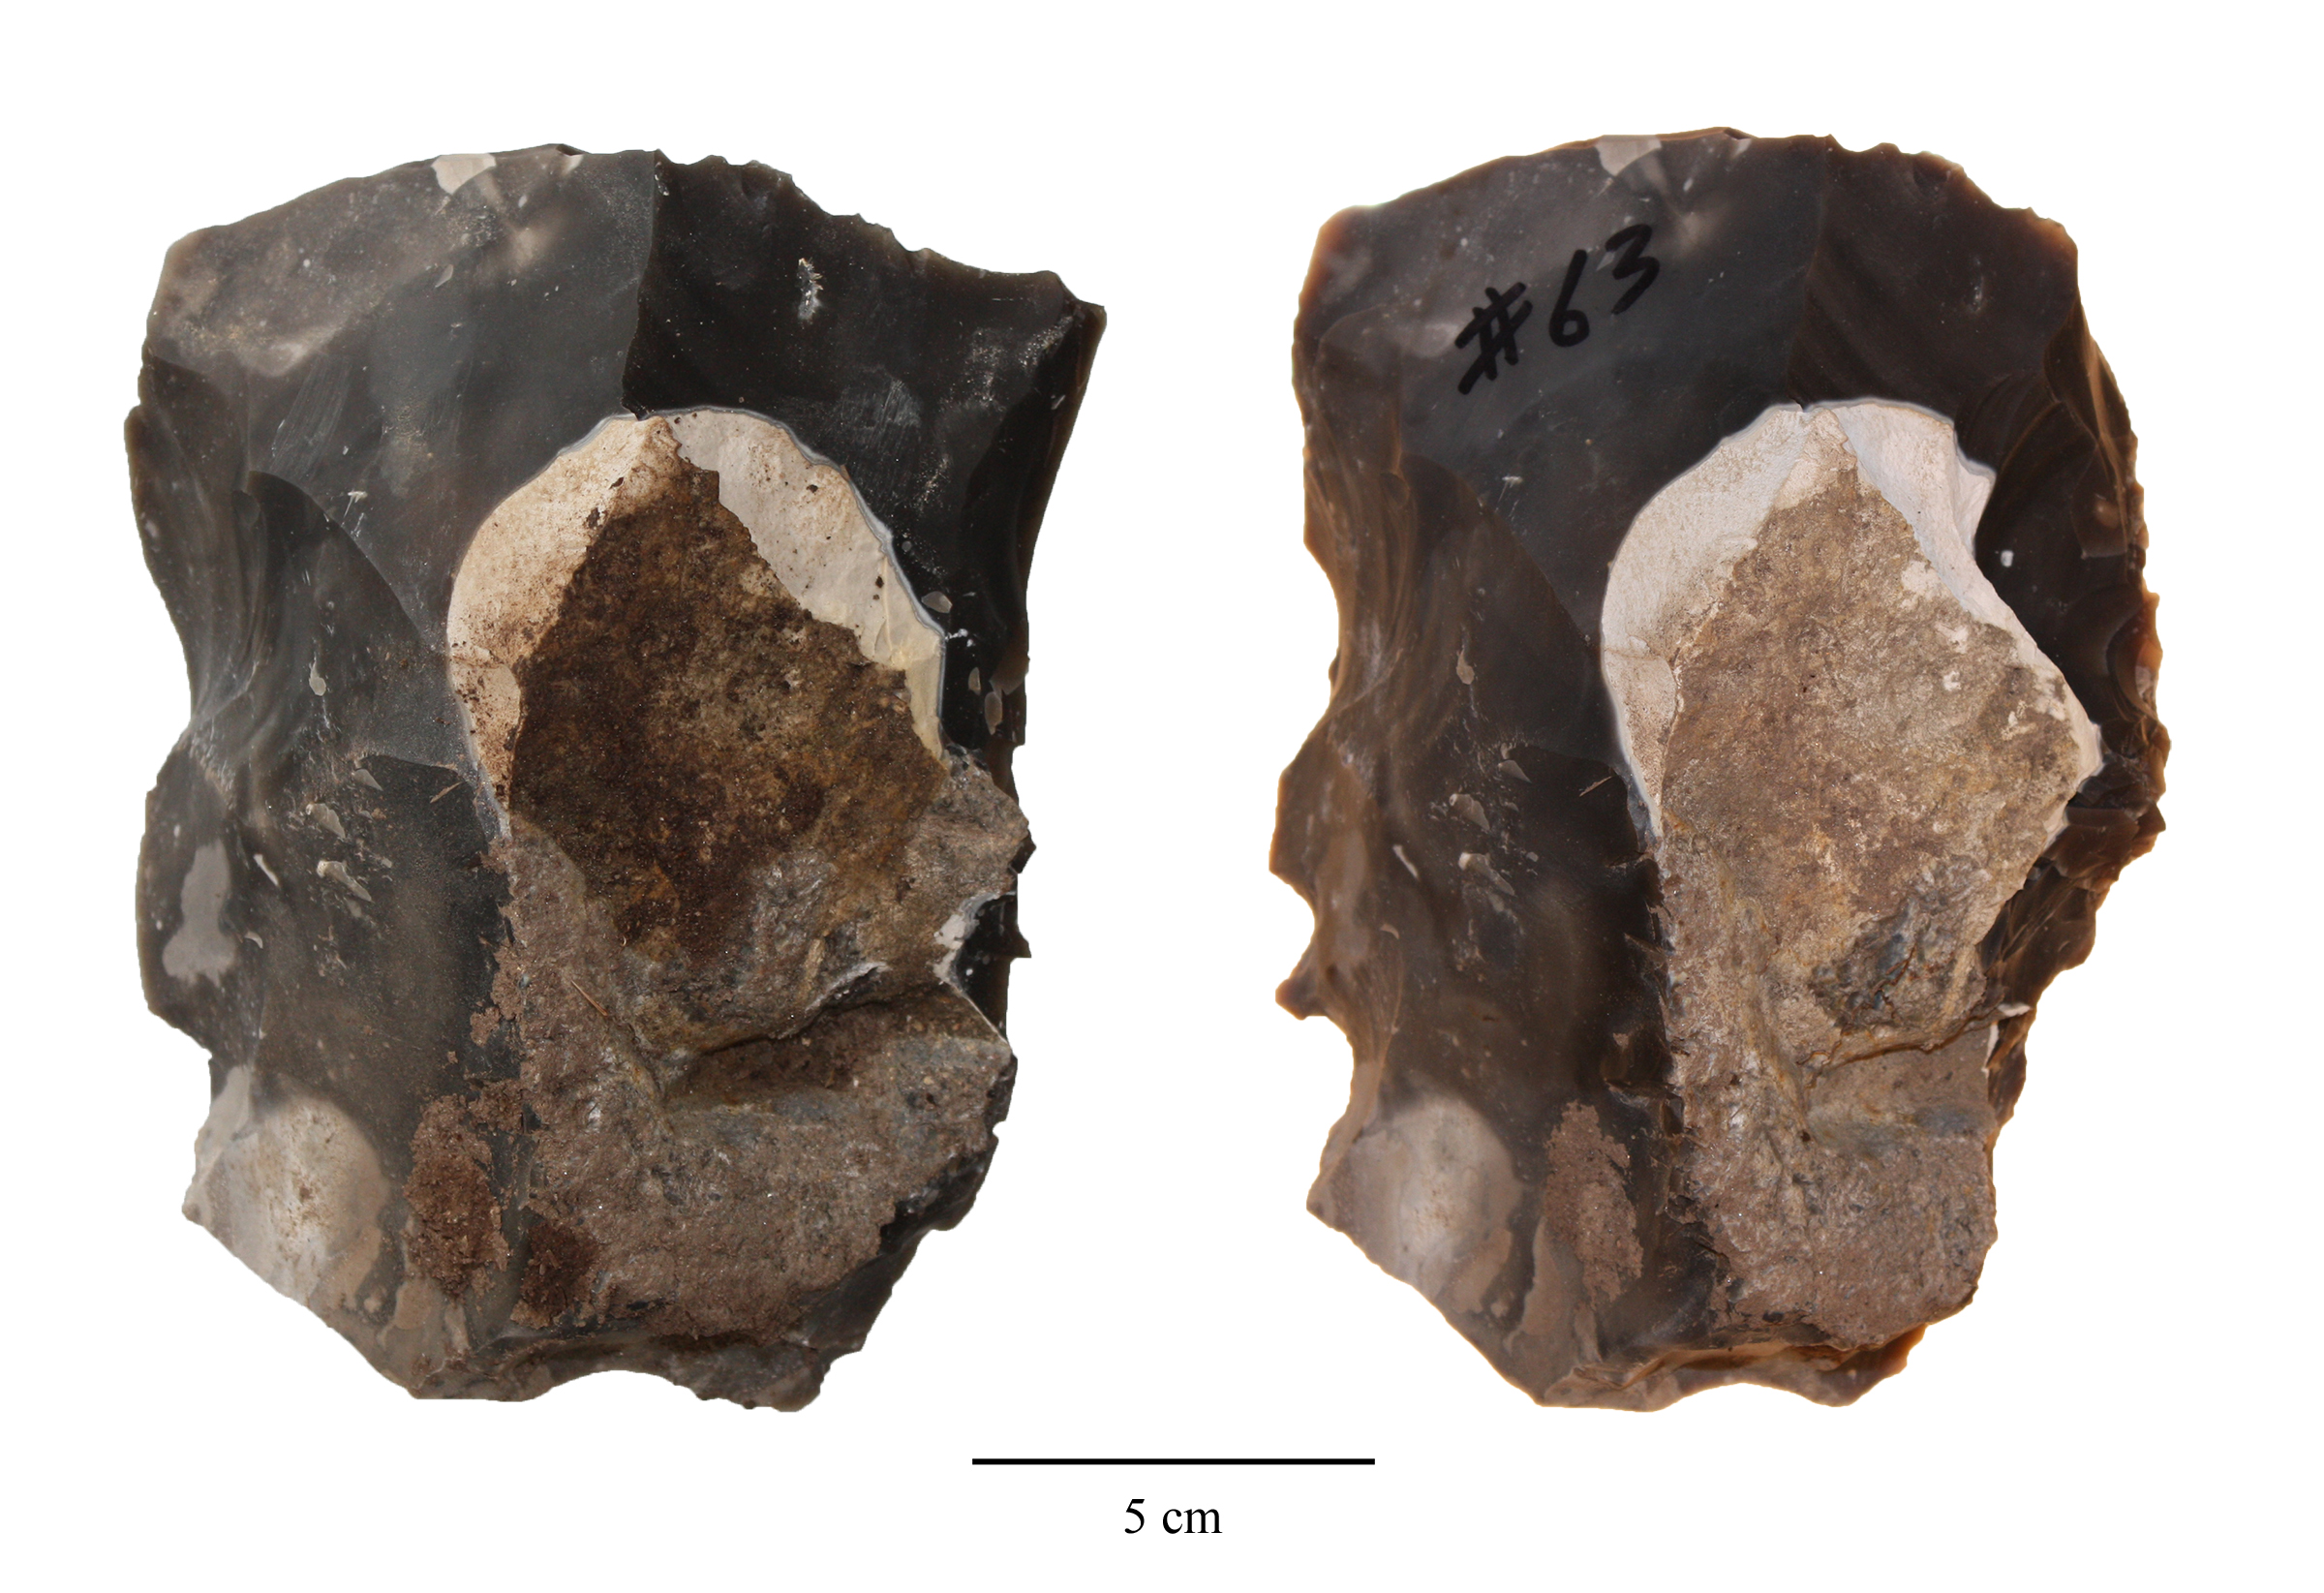

Core 63 before (left) and after knapping(right), showing the minimal morphological change during the knapping process.

Although we are not the first research team to use secondary archaeological data (e.g., Key, 2019), we would still like to highlight here that this research project further exemplifys the potential of reusing old archaeological data in digital format to address novel research questions. In this paper, the main source of archaeological data is a collection of photos produced and curated more than 10 years ago, and the morphological variation data of the experimental collection are also derived from photographs instead of remeasurements of the original artifacts. Given the irreversible nature of archaeological excavations, digitized data, be it text, pictures, or videos, often become the sole evidence that is available for certain research questions. Yet, it has been widely acknowledged that the reuse of archaeological data has not received enough attention among researchers in our discipline (Faniel et al., 2018; Huggett, 2018; Moody et al., 2021). Among many reasons preventing archaeologists from reusing published and digitized data (Sobotkova, 2018), the lack of a standardized practice of and motivation for data sharing is a prominent one (Marwick & Birch, 2018). As stated in the method section, we addressed this issue by sharing the raw data and the code for generating the derived data on an open-access repository. Another major and legitimate concern of archaeological data reuse is their quality. In terms of this aspect, we do acknowledge the limitations of relying on photos when it comes to the more detailed technological analysis of stone artifacts, however, our paper shows that finding the appropriate research questions given the data available is key to revealing new novel insights into the studied topic. Moreover, we believe that this type of research has a strong contemporary relevance due to the continued influence of the COVID-19 on fieldwork-related travel and direct access to archaeological artifacts (Balandier et al., 2022; Ogundiran, 2021).

# Conclusions

Regarding the two research questions we proposed in the beginning, our case study suggested that 1) we can delineate the effects of skill level and mental template through the multivariate analysis of morphometric data, where the former is associated with cross-sectional thinning while the latter is reflected in elongation and pointedness; 2) On average training has an immediate effect of making novices to better understand the shared design targets, but 90 hours of training is still not enough for novice to reach the level of expertise as reflected in modern experienced knappers, let alone the Boxgrove tool makers, which supports our differential cultural reproduction hypothesis. At a larger theoretical level it questions the distinction between social learning of design targets vs. individual learning of the skills needed to achieve them. Traditionally archaeological experiments speaking to the literature of cultural evolution tend to use handaxe as a model artifact and focus on how copying errors emerge during the transmission of a fixed and static target using transmission chain design and alternative raw materials such as foam (Schillinger et al., 2014b, 2017, 2015). This line of inquiry is generally characterized by high internal validity (causal mechanisms) but low external validity (generalizability to archaeological data). In contrast, our study unpacks the differential reproductions of two major sources of variation and reveals how the development of motor skill during learning is constraining the achievement of the socially learnt design target, through an actualistic experimental setting featuring a higher degree of external validity (Liu & Stout, 2022). In the future, more robust experimental studies are needed to deepen our understanding of the relationship between skill acquisition and the morphological variability of handaxes in the proper developmental context (Högberg, 2018; Lew-Levy et al., 2020; Nowell, 2021) as well as their implications for the biological and cultural evolution of the hominin lineages.

# Table

# CRediT authorship contribution statement

**Cheng Liu**: Conceptualization, Data curation, Formal analysis, Investigation, Methodology, Visualization, Writing – original draft, Writing – review & editing. **Nada Khreisheh**: Investigation, Writing – review & editing. **Dietrich Stout**: Conceptualization, Investigation, Resources, Funding acquisition, Supervision, Writing – original draft, Writing – review & editing. **Justin Pargeter**: Conceptualization, Investigation, Methodology, Supervision, Writing – original draft, Writing – review & editing.

# Declaration of competing interest

The authors declare that they have no known competing financial interests or personal relationships that could have appeared to influence the work reported in this paper.

# Acknowledgements

We would like to thank Thomas Jennings and three other anonymous reviewers for their insightful feedback on an earlier draft of this manuscript. This work was supported by funding from the National Science Foundation of the USA (grants SMA-1328567 & DRL-1631563), the John Templeton Foundation (grant 47994), and the Emory University Research Council. The handaxe knapping skill acquisition experiment involved in this study was approved by Emory University’s Internal Review Board (IRB study no: 00067237). We would also like to thank Radu Iovita for providing us access to the digital photographs of the Boxgrove handaxe assemblage.

# References

Ashton, N., & Davis, R. (2021). Cultural mosaics, social structure, and identity: The Acheulean threshold in Europe. *Journal of Human Evolution*, *156*, 103011. <https://doi.org/10.1016/j.jhevol.2021.103011>

Balandier, C., Cipin, I., Hartenberger, B., & Islam, M. (2022). Archaeology in a pandemic: Four stories. *Near Eastern Archaeology*, *85*(1), 66–73. <https://doi.org/10.1086/718201>

Bamforth, D. B., & Finlay, N. (2008). Introduction: Archaeological approaches to lithic production skill and craft learning. *Journal of Archaeological Method and Theory*, *15*(1), 1–27. <https://www.jstor.org/stable/40345992>

Bayani, K. Y. T., Natraj, N., Khresdish, N., Pargeter, J., Stout, D., & Wheaton, L. A. (2021). Emergence of perceptuomotor relationships during paleolithic stone toolmaking learning: intersections of observation and practice. *Communications Biology*, *4*(1), 1–12. <https://doi.org/10.1038/s42003-021-02768-w>

Bello, S. M., Parfitt, S. A., & Stringer, C. (2009). Quantitative micromorphological analyses of cut marks produced by ancient and modern handaxes. *Journal of Archaeological Science*, *36*(9), 1869–1880. <https://doi.org/10.1016/j.jas.2009.04.014>

Bradley, B. A., & Sampson, C. G. (1986). *Analysis by replication of two acheuleian artefact assemblages from caddington, england* (G. Bailey & P. Callow, Eds.; pp. 29–46). Cambridge University Press.

Callahan, E. (1979). The basics of biface knapping in the eastern fluted point tradition: A manual for flintknappers and lithic analysts. *Archaeology of Eastern North America*, *7*(1), 1–180. <https://www.jstor.org/stable/40914177>

Caruana, M. V. (2022). Extrapolating later acheulian handaxe reduction sequences in south africa: A case study from the cave of hearths and amanzi springs. *Lithic Technology*, *47*(1), 1–12. <https://doi.org/10.1080/01977261.2021.1924452>

Caruana, M. V. (2020). South African handaxes reloaded. *Journal of Archaeological Science: Reports*, *34*, 102649. <https://doi.org/10.1016/j.jasrep.2020.102649>

Caruana, M. V., & Herries, A. I. R. (2021). Modelling production mishaps in later Acheulian handaxes from the Area 1 excavation at Amanzi Springs (Eastern Cape, South Africa) and their effects on reduction and morphology. *Journal of Archaeological Science: Reports*, *39*, 103121. <https://doi.org/10.1016/j.jasrep.2021.103121>

Charbonneau, M., & Strachan, J. W. A. (2022). From Copying to Coordination: An Alternative Framework for Understanding Cultural Learning Mechanisms. *Journal of Cognition and Culture*, *22*(5), 451–466. <https://doi.org/10.1163/15685373-12340145>

Clark, J. D. (2001). *Variability in primary and secondary technologies of the later acheulian in africa* (S. Milliken & J. Cook, Eds.; p. 118). Oxbow Books.

Connolly, K., & Dalgleish, M. (1989). The emergence of a tool-using skill in infancy. *Developmental Psychology*, *25*(6), 894–912. <https://doi.org/10.1037/0012-1649.25.6.894>

Corbey, R. (2020). Baldwin effects in early stone tools. *Evolutionary Anthropology: Issues, News, and Reviews*, *29*(5), 237–244. <https://doi.org/10.1002/evan.21864>

Corbey, R., Jagich, A., Vaesen, K., & Collard, M. (2016). The acheulean handaxe: More like a bird’s song than a beatles’ tune? *Evolutionary Anthropology: Issues, News, and Reviews*, *25*(1), 6–19. <https://doi.org/10.1002/evan.21467>

Crompton, R. H., & Gowlett, J. A. J. (1993). Allometry and multidimensional form in Acheulean bifaces from Kilombe, Kenya. *Journal of Human Evolution*, *25*(3), 175–199. <https://doi.org/10.1006/jhev.1993.1043>

Davis, R., & Ashton, N. (2019). Landscapes, environments and societies: The development of culture in Lower Palaeolithic Europe. *Journal of Anthropological Archaeology*, *56*, 101107. <https://doi.org/10.1016/j.jaa.2019.101107>

Deetz, J. (1967). *Invitation to archaeology*. Natural History Press.

Driscoll, K., & García-Rojas, M. (2014). Their lips are sealed: identifying hard stone, soft stone, and antler hammer direct percussion in Palaeolithic prismatic blade production. *Journal of Archaeological Science*, *47*, 134–141. <https://doi.org/10.1016/j.jas.2014.04.008>

Eerkens, J. W., & Lipo, C. P. (2005). Cultural transmission, copying errors, and the generation of variation in material culture and the archaeological record. *Journal of Anthropological Archaeology*, *24*(4), 316–334. <https://doi.org/10.1016/j.jaa.2005.08.001>

Eerkens, J. W., & Lipo, C. P. (2007). Cultural transmission theory and the archaeological record: Providing context to understanding variation and temporal changes in material culture. *Journal of Archaeological Research*, *15*(3), 239274. https://doi.org/<https://doi.org/10.1007/s10814-007-9013-z>

Eren, M. I., Roos, C. I., Story, B. A., von Cramon-Taubadel, N., & Lycett, S. J. (2014). The role of raw material differences in stone tool shape variation: an experimental assessment. *Journal of Archaeological Science*, *49*, 472–487. <https://doi.org/10.1016/j.jas.2014.05.034>

Faisal, A., Stout, D., Apel, J., & Bradley, B. (2010). The Manipulative Complexity of Lower Paleolithic Stone Toolmaking. *PLOS ONE*, *5*(11), e13718. <https://doi.org/10.1371/journal.pone.0013718>

Faniel, I. M., Austin, A., Kansa, E., Kansa, S. W., France, P., Jacobs, J., Boytner, R., & Yakel, E. (2018). Beyond the Archive: Bridging Data Creation and Reuse in Archaeology. *Advances in Archaeological Practice*, *6*(2), 105–116. <https://doi.org/10.1017/aap.2018.2>

Games, P. A., & Howell, J. F. (1976). Pairwise multiple comparison procedures with unequal n’s and/or variances: A monte carlo study. *Journal of Educational Statistics*, *1*(2), 113–125. <https://doi.org/10.2307/1164979>

García-Medrano, P., Ashton, N., Moncel, M.-H., & Ollé, A. (2020). The WEAP method: A new age in the analysis of the Acheulean handaxess. *Journal of Paleolithic Archaeology*, *3*(4). <https://doi.org/10.1007/s41982-020-00054-5>

García-Medrano, P., Maldonado-Garrido, E., Ashton, N., & Ollé, A. (2020). Objectifying processes: The use of geometric morphometrics and multivariate analyses on Acheulean tools. *Journal of Lithic Studies*, *7*(1). <https://doi.org/10.2218/jls.4327>

García-Medrano, P., Ollé, A., Ashton, N., & Roberts, M. B. (2019). The Mental Template in Handaxe Manufacture: New Insights into Acheulean Lithic Technological Behavior at Boxgrove, Sussex, UK. *Journal of Archaeological Method and Theory*, *26*(1), 396–422. <https://doi.org/10.1007/s10816-018-9376-0>

García-Medrano, P., Shipton, C., White, M., & Ashton, N. (2022). Acheulean diversity in britain (MIS 15-MIS11): From the standardization to the regionalization of technology. *Frontiers in Earth Science*, *10*. <https://www.frontiersin.org/articles/10.3389/feart.2022.917207>

Gowlett, J. A. J. (2021). Deep structure in the Acheulean adaptation: technology, sociality and aesthetic emergence. *Adaptive Behavior*, *29*(2), 197–216. <https://doi.org/10.1177/1059712320965713>

Gowlett, J. A. J. (2006). *The elements of design form in acheulian bifaces: Modes, modalities, rules and language* (N. Goren-Inbar & G. Sharon, Eds.; pp. 203–222). Equinox.

Herzlinger, G., Goren-Inbar, N., & Grosman, L. (2017). A new method for 3D geometric morphometric shape analysis: The case study of handaxe knapping skill. *Journal of Archaeological Science: Reports*, *14*, 163–173. <https://doi.org/10.1016/j.jasrep.2017.05.013>

Hillson, S. W., Parfitt, S. A., Bello, S. M., Roberts, M. B., & Stringer, C. B. (2010). Two hominin incisor teeth from the middle Pleistocene site of Boxgrove, Sussex, England. *Journal of Human Evolution*, *59*(5), 493–503. <https://doi.org/10.1016/j.jhevol.2010.06.004>

Hodgson, D. (2015). The symmetry of Acheulean handaxes and cognitive evolution. *Journal of Archaeological Science: Reports*, *2*, 204–208. <https://doi.org/10.1016/j.jasrep.2015.02.002>

Högberg, A. (2018). Approaches to children’s knapping in lithic technology studies. *Revista de Arqueologia*, *31*(2), 58–74. <https://doi.org/10.24885/sab.v31i2.613>

Holmes, J. A., Atkinson, T., Fiona Darbyshire, D. P., Horne, D. J., Joordens, J., Roberts, M. B., Sinka, K. J., & Whittaker, J. E. (2010). Middle Pleistocene climate and hydrological environment at the Boxgrove hominin site (West Sussex, UK) from ostracod records. *Quaternary Science Reviews*, *29*(13), 1515–1527. <https://doi.org/10.1016/j.quascirev.2009.02.024>

Huggett, J. (2018). Reuse Remix Recycle: Repurposing Archaeological Digital Data. *Advances in Archaeological Practice*, *6*(2), 93–104. <https://doi.org/10.1017/aap.2018.1>

Hutchence, L., & Debackere, S. (2019). An evaluation of behaviours considered indicative of skill in handaxe manufacture. *LithicsThe Journal of the Lithic Studies Society*, *39*, 36.

Hutchence, L., & Scott, C. (2021). Is Acheulean Handaxe Shape the Result of Imposed ‘Mental Templates’ or Emergent in Manufacture? Dissolving the Dichotomy through Exploring ‘Communities of Practice’ at Boxgrove, UK. *Cambridge Archaeological Journal*, *31*(4), 675–686. <https://doi.org/10.1017/S0959774321000251>

Iovita, R., & McPherron, S. P. (2011). The handaxe reloaded: A morphometric reassessment of Acheulian and Middle Paleolithic handaxes. *Journal of Human Evolution*, *61*(1), 61–74. <https://doi.org/10.1016/j.jhevol.2011.02.007>

Iovita, R., Tuvi-Arad, I., Moncel, M.-H., Despriée, J., Voinchet, P., & Bahain, J.-J. (2017). High handaxe symmetry at the beginning of the European Acheulian: The data from la Noira (France) in context. *PLOS ONE*, *12*(5), e0177063. <https://doi.org/10.1371/journal.pone.0177063>

Isaac, G. L. (1986). *Foundation stones: Early artefacts as indicators of activities and abilities* (G. Bailey & P. Callow, Eds.; pp. 221–241). Cambridge University Press.

Kempe, M., Lycett, S., & Mesoudi, A. (2012). An experimental test of the accumulated copying error model of cultural mutation for Acheulean handaxe size. *PLOS ONE*, *7*(11), e48333. <https://doi.org/10.1371/journal.pone.0048333>

Key, A. J. M. (2019). Handaxe shape variation in a relative context. *Comptes Rendus Palevol*, *18*(5), 555–567. <https://doi.org/10.1016/j.crpv.2019.04.008>

Key, A. J. M., & Lycett, S. J. (2017). Influence of Handaxe Size and Shape on Cutting Efficiency: A Large-Scale Experiment and Morphometric Analysis. *Journal of Archaeological Method and Theory*, *24*(2), 514–541. <https://doi.org/10.1007/s10816-016-9276-0>

Key, A. J. M., & Lycett, S. J. (2019). Biometric variables predict stone tool functional performance more effectively than tool-form attributes: a case study in handaxe loading capabilities. *Archaeometry*, *61*(3), 539–555. <https://doi.org/10.1111/arcm.12439>

Key, A. J. M., Proffitt, T., Stefani, E., & Lycett, S. J. (2016). Looking at handaxes from another angle: Assessing the ergonomic and functional importance of edge form in Acheulean bifaces. *Journal of Anthropological Archaeology*, *44*, 43–55. <https://doi.org/10.1016/j.jaa.2016.08.002>

Khreisheh, N. N., Davies, D., & Bradley, B. A. (2013). Extending Experimental Control: The Use of Porcelain in Flaked Stone Experimentation. *Advances in Archaeological Practice*, *1*(1), 38–46. <https://doi.org/10.7183/2326-3768.1.1.37>

Kohn, M., & Mithen, S. (1999). Handaxes: products of sexual selection? *Antiquity*, *73*(281), 518–526. <https://doi.org/10.1017/S0003598X00065078>

Kolhatkar, M. (2022). Skill in Stone Knapping: an Ecological Approach. *Journal of Archaeological Method and Theory*, *29*(1), 251–304. <https://doi.org/10.1007/s10816-021-09521-x>

Laland, K. N., Uller, T., Feldman, M. W., Sterelny, K., Müller, G. B., Moczek, A., Jablonka, E., & Odling-Smee, J. (2015). The extended evolutionary synthesis: Its structure, assumptions and predictions. *Proceedings of the Royal Society B: Biological Sciences*, *282*(1813), 20151019. <https://doi.org/10.1098/rspb.2015.1019>

Le Tensorer, J.-M. (2006). Les cultures acheuléennes et la question de l’émergence de la pensée symbolique chez Homo erectus à partir des données relatives à la forme symétrique et harmonique des bifaces. *Comptes Rendus Palevol*, *5*(1), 127–135. <https://doi.org/10.1016/j.crpv.2005.12.003>

Lê, S., Josse, J., & Husson, F. (2008). FactoMineR: An R Package for Multivariate Analysis. *Journal of Statistical Software*, *25*, 1–18. <https://doi.org/10.18637/jss.v025.i01>

Lewis, A. R., Williams, J. C., Buchanan, B., Walker, R. S., Eren, M. I., & Bebber, M. R. (2022). Knapping quality of local versus exotic Upper Mercer chert (Ohio, USA) during the Holocene. *Geoarchaeology*, *37*(3), 486–496. <https://doi.org/10.1002/gea.21904>

Lew-Levy, S., Milks, A., Lavi, N., Pope, S. M., & Friesem, D. E. (2020). Where innovations flourish: An ethnographic and archaeological overview of huntergatherer learning contexts. *Evolutionary Human Sciences*, *2*, e31. <https://doi.org/10.1017/ehs.2020.35>

Liu, C., & Stout, D. (2022). Inferring cultural reproduction from lithic data: A critical review. *Evolutionary anthropology*. <https://doi.org/10.1002/evan.21964>

Lockey, A. L., Rodríguez, L., Martín-Francés, L., Arsuaga, J. L., Bermúdez de Castro, J. M., Crété, L., Martinón-Torres, M., Parfitt, S., Pope, M., & Stringer, C. (2022). Comparing the Boxgrove and Atapuerca (Sima de los Huesos) human fossils: Do they represent distinct paleodemes? *Journal of Human Evolution*, *172*, 103253. <https://doi.org/10.1016/j.jhevol.2022.103253>

Lycett, S. J., & Cramon-Taubadel, N. von. (2015). Toward a “Quantitative Genetic” Approach to Lithic Variation. *Journal of Archaeological Method and Theory*, *22*(2), 646–675. <https://doi.org/10.1007/s10816-013-9200-9>

Lycett, S. J., & Gowlett, J. A. J. (2008). On questions surrounding the acheulean ’tradition’. *World Archaeology*, *40*(3), 295–315. <https://www.jstor.org/stable/40388215>

Lycett, S. J., Schillinger, K., Eren, M. I., von Cramon-Taubadel, N., & Mesoudi, A. (2016). Factors affecting Acheulean handaxe variation: Experimental insights, microevolutionary processes, and macroevolutionary outcomes. *Quaternary International*, *411*, 386–401. <https://doi.org/10.1016/j.quaint.2015.08.021>

Lycett, S. J., von Cramon-Taubadel, N., & Foley, R. A. (2006). A crossbeam co-ordinate caliper for the morphometric analysis of lithic nuclei: a description, test and empirical examples of application. *Journal of Archaeological Science*, *33*(6), 847–861. <https://doi.org/10.1016/j.jas.2005.10.014>

Lyman, R. L., & O’Brien, M. J. (2004). A History of Normative Theory in Americanist Archaeology. *Journal of Archaeological Method and Theory*, *11*(4), 369–396. <https://doi.org/10.1007/s10816-004-1420-6>

Machin, A. J., Hosfield, R. T., & Mithen, S. J. (2007). Why are some handaxes symmetrical? Testing the influence of handaxe morphology on butchery effectiveness. *Journal of Archaeological Science*, *34*(6), 883–893. <https://doi.org/10.1016/j.jas.2006.09.008>

Marwick, B. (2017). Computational Reproducibility in Archaeological Research: Basic Principles and a Case Study of Their Implementation. *Journal of Archaeological Method and Theory*, *24*(2), 424–450. <https://doi.org/10.1007/s10816-015-9272-9>

Marwick, B., & Birch, S. E. P. (2018). A Standard for the Scholarly Citation of Archaeological Data as an Incentive to Data Sharing. *Advances in Archaeological Practice*, *6*(2), 125–143. <https://doi.org/10.1017/aap.2018.3>

McNabb, J., Binyon, F., & Hazelwood, L. (2004). The large cutting tools from the south african acheulean and the question of social traditions. *Current Anthropology*, *45*(5), 653–677. <https://doi.org/10.1086/423973>

McNabb, J., & Cole, J. (2015). The mirror cracked: Symmetry and refinement in the Acheulean handaxe. *Journal of Archaeological Science: Reports*, *3*, 100–111. <https://doi.org/10.1016/j.jasrep.2015.06.004>

Milks, A. (2019). Skills shortage: a critical evaluation of the use of human participants in early spear experiments. *EXARC Journal*, *2019*(2), 1–11. <https://pdf.printfriendly.com/pdfs/make>

Moncel, M.-H., Arzarello, M., Boëda, É., Bonilauri, S., Chevrier, B., Gaillard, C., Forestier, H., Yinghua, L., Sémah, F., & Zeitoun, V. (2018a). Assemblages with bifacial tools in Eurasia (third part). Considerations on the bifacial phenomenon throughout Eurasia. *Comptes Rendus Palevol*, *17*(1), 77–97. <https://doi.org/10.1016/j.crpv.2015.11.007>

Moncel, M.-H., Arzarello, M., Boëda, É., Bonilauri, S., Chevrier, B., Gaillard, C., Forestier, H., Yinghua, L., Sémah, F., & Zeitoun, V. (2018b). The assemblages with bifacial tools in Eurasia (first part). What is going on in the West? Data on western and southern Europe and the Levant. *Comptes Rendus Palevol*, *17*(1), 45–60. <https://doi.org/10.1016/j.crpv.2015.09.009>

Moncel, M.-H., Arzarello, M., Boëda, É., Bonilauri, T., Chevrier, B., Gaillard, C., Forestier, H., Yinghua, L., Sémah, F., & Zeitoun, V. (2018c). Assemblages with bifacial tools in Eurasia (second part). What is going on in the East? Data from India, Eastern Asia and Southeast Asia. *Comptes Rendus Palevol*, *17*(1), 61–76. <https://doi.org/10.1016/j.crpv.2015.09.010>

Moody, B., Dye, T., May, K., Wright, H., & Buck, C. (2021). Digital chronological data reuse in archaeology: Three case studies with varying purposes and perspectives. *Journal of Archaeological Science: Reports*, *40*, 103188. <https://doi.org/10.1016/j.jasrep.2021.103188>

Moore, M. W. (2020). Hominin Stone Flaking and the Emergence of ‘Top-down’ Design in Human Evolution. *Cambridge Archaeological Journal*, *30*(4), 647–664. <https://doi.org/10.1017/S0959774320000190>

Moore, M. W. (2011). The design space of stone flaking: Implications for cognitive evolution. *World Archaeology*, *43*(4), 702–715. <https://doi.org/10.1080/00438243.2011.624778>

Moore, M. W., & Perston, Y. (2016). Experimental Insights into the Cognitive Significance of Early Stone Tools. *PLOS ONE*, *11*(7), e0158803. <https://doi.org/10.1371/journal.pone.0158803>

Nowell, A. (2021). *Growing up in the ice age: Fossil and archaeological evidence of the lived lives of plio-pleistocene children*. Oxbow Books.

Nowell, A. (2002). Coincidental factors of handaxe morphology. *Behavioral and Brain Sciences*, *25*(3), 413–414. <https://doi.org/10.1017/S0140525X02330073>

Nowell, A., & White, M. (2010). *Growing up in the middle pleistocene: Life history strategies and their relationship to acheulian industries.* (A. Nowell & I. Davidson, Eds.; pp. 67–82). University Press of Colorado. <http://www.upcolorado.com/book/Stone_Tools_and_the_Evolution_of_Human_Cognition_Paper>

Ogundiran, A. (2021). Doing Archaeology in a Turbulent Time. *African Archaeological Review*, *38*(3), 397–401. <https://doi.org/10.1007/s10437-021-09460-8>

Pargeter, J., Khreisheh, N., Shea, J. J., & Stout, D. (2020). Knowledge vs. know-how? Dissecting the foundations of stone knapping skill. *Journal of Human Evolution*, *145*, 102807. <https://doi.org/10.1016/j.jhevol.2020.102807>

Pargeter, J., Khreisheh, N., & Stout, D. (2019). Understanding stone tool-making skill acquisition: Experimental methods and evolutionary implications. *Journal of Human Evolution*, *133*, 146–166. <https://doi.org/10.1016/j.jhevol.2019.05.010>

Patil, I. (2021). Visualizations with statistical details: The ’ggstatsplot’ approach. *Journal of Open Source Software*, *6*(61), 3167. <https://doi.org/10.21105/joss.03167>

Pelcin, A. (1997). The Effect of Indentor Type on Flake Attributes: Evidence from a Controlled Experiment. *Journal of Archaeological Science*, *24*(7), 613–621. <https://doi.org/10.1006/jasc.1996.0145>

Pelegrin, J. (1993). *A framework for analysing prehistoric stone tool manufacture and a tentative application to some early stone industries* (pp. 302–317). Oxford University Press. <https://doi.org/10.1093/acprof:oso/9780198522638.003.0018>

Petraglia, M. D., & Korisettar, R. (Eds.). (1998). *Early human behaviour in global context: The rise and diversity of the lower palaeolithic record*. Routledge. <https://doi.org/10.4324/9780203203279>

Pope, M., Parfitt, S., & Roberts, M. (2020). *The horse butchery site 2020: A high-resolution record of lower palaeolithic hominin behviour at boxgrove, UK*. SpoilHeap Publications.

Preece, R. C., & Parfitt, S. A. (2022). Environmental heterogeneity of the Lower Palaeolithic land surface on the Goodwood-Slindon Raised Beach: comparisons of the records from Boxgrove and Valdoe, Sussex, UK. *Journal of Quaternary Science*, *37*(4), 572–592. <https://doi.org/10.1002/jqs.3409>

R Core Team. (2021). *R: A language and environment for statistical computing*. R Foundation for Statistical Computing. <https://www.R-project.org/>

Richerson, P. J., & Boyd, R. (2005). *Not By Genes Alone: How Culture Transformed Human Evolution*. University of Chicago Press.

Roberts, M. B., & Parfitt, S. A. (1998). *Boxgrove: A middle pleistocene hominid site at eartham quarry, boxgrove, west sussex*. English Heritage.

Roberts, M. B., & Pope, M. (2009). *The archaeological and sedimentary records from boxgrove and slindon* (R. M. Briant, M. R. Bates, R. Hosfield, & F. Wenban-Smith, Eds.; pp. 96–122). Quaternary Research Association.

Roberts, M. B., Stringer, C. B., & Parfitt, S. A. (1994). A hominid tibia from Middle Pleistocene sediments at Boxgrove, UK. *Nature*, *369*(6478), 311–313. <https://doi.org/10.1038/369311a0>

Roe, D. A. (1969). British Lower and Middle Palaeolithic Handaxe Groups*. *Proceedings of the Prehistoric Society*, *34*, 1–82. <https://doi.org/10.1017/S0079497X00013840>

Roux, V., Bril, B., & Dietrich, G. (1995). Skills and learning difficulties involved in stone knapping: The case of stone-bead knapping in khambhat, india. *World Archaeology*, *27*(1), 63–87. <https://doi.org/10.1080/00438243.1995.9980293>

Rueden, C. T., Schindelin, J., Hiner, M. C., DeZonia, B. E., Walter, A. E., Arena, E. T., & Eliceiri, K. W. (2017). ImageJ2: ImageJ for the next generation of scientific image data. *BMC Bioinformatics*, *18*(1), 529. <https://doi.org/10.1186/s12859-017-1934-z>

Sauder, D. C., & DeMars, C. E. (2019). An Updated Recommendation for Multiple Comparisons. *Advances in Methods and Practices in Psychological Science*, *2*(1), 26–44. <https://doi.org/10.1177/2515245918808784>

Schick, K. D., & Toth, N. P. (1993). *Making Silent Stones Speak: Human Evolution And The Dawn Of Technology*. Simon; Schuster.

Schillinger, K., Mesoudi, A., & Lycett, S. J. (2014a). Copying error and the cultural evolution of “additive” vs. “Reductive” material traditions: An experimental assessment. *American Antiquity*, *79*(1), 128–143. <https://doi.org/10.7183/0002-7316.79.1.128>

Schillinger, K., Mesoudi, A., & Lycett, S. J. (2014b). Considering the Role of Time Budgets on Copy-Error Rates in Material Culture Traditions: An Experimental Assessment. *PLOS ONE*, *9*(5), e97157. <https://doi.org/10.1371/journal.pone.0097157>

Schillinger, K., Mesoudi, A., & Lycett, S. J. (2017). Differences in Manufacturing Traditions and Assemblage-Level Patterns: the Origins of Cultural Differences in Archaeological Data. *Journal of Archaeological Method and Theory*, *24*(2), 640–658. <https://doi.org/10.1007/s10816-016-9280-4>

Schillinger, K., Mesoudi, A., & Lycett, S. J. (2015). The impact of imitative versus emulative learning mechanisms on artifactual variation: implications for the evolution of material culture. *Evolution and Human Behavior*, *36*(6), 446–455. <https://doi.org/10.1016/j.evolhumbehav.2015.04.003>

Sharon, G. (2008). The impact of raw material on Acheulian large flake production. *Journal of Archaeological Science*, *35*(5), 1329–1344. <https://doi.org/10.1016/j.jas.2007.09.004>

Sharon, G., Alperson-Afil, N., & Goren-Inbar, N. (2011). Cultural conservatism and variability in the Acheulian sequence of Gesher Benot Ya‘aqov. *Journal of Human Evolution*, *60*(4), 387–397. <https://doi.org/10.1016/j.jhevol.2009.11.012>

Shipton, C., & Clarkson, C. (2015). Handaxe reduction and its influence on shape: An experimental test and archaeological case study. *Journal of Archaeological Science: Reports*, *3*, 408–419. <https://doi.org/10.1016/j.jasrep.2015.06.029>

Shipton, C., Clarkson, C., Pal, J. N., Jones, S. C., Roberts, R. G., Harris, C., Gupta, M. C., Ditchfield, P. W., & Petraglia, M. D. (2013). Generativity, hierarchical action and recursion in the technology of the Acheulean to Middle Palaeolithic transition: A perspective from Patpara, the Son Valley, India. *Journal of Human Evolution*, *65*(2), 93–108. <https://doi.org/10.1016/j.jhevol.2013.03.007>

Shipton, C., Petraglia, M. D., & Paddayya, K. (2009). Stone tool experiments and reduction methods at the Acheulean site of Isampur Quarry, India. *Antiquity*, *83*(321), 769–785. <https://doi.org/10.1017/S0003598X00098987>

Shipton, C., & White, M. (2020). Handaxe types, colonization waves, and social norms in the British Acheulean. *Journal of Archaeological Science: Reports*, *31*, 102352. <https://doi.org/10.1016/j.jasrep.2020.102352>

Smith, G. M. (2013). Taphonomic resolution and hominin subsistence behaviour in the Lower Palaeolithic: differing data scales and interpretive frameworks at Boxgrove and Swanscombe (UK). *Journal of Archaeological Science*, *40*(10), 3754–3767. <https://doi.org/10.1016/j.jas.2013.05.002>

Smith, G. M. (2012). Hominin-carnivore interaction at the Lower Palaeolithic site of Boxgrove, UK. *Journal of taphonomy*, *10*(3-4), 373–394. <https://dialnet.unirioja.es/servlet/articulo?codigo=5002455>

Sobotkova, A. (2018). Sociotechnical Obstacles to Archaeological Data Reuse. *Advances in Archaeological Practice*, *6*(2), 117–124. <https://doi.org/10.1017/aap.2017.37>

Spikins, P. (2012). Goodwill hunting? Debates over the ‘meaning’ of lower palaeolithic handaxe form revisited. *World Archaeology*, *44*(3), 378–392. <https://doi.org/10.1080/00438243.2012.725889>

Sterelny, K. (2004). A review of Evolution and learning: the Baldwin effect reconsidered edited by Bruce Weber and David Depew. *Evolution & Development*, *6*(4), 295–300. <https://doi.org/10.1111/j.1525-142X.2004.04035.x>

Stout, D. (2021). The cognitive science of technology. *Trends in Cognitive Sciences*, *25*(11), 964–977. <https://doi.org/10.1016/j.tics.2021.07.005>

Stout, D. (2002). Skill and cognition in stone tool production: An ethnographic case study from irian jaya. *Current Anthropology*, *43*(5), 693–722. <https://doi.org/10.1086/342638>

Stout, D., Apel, J., Commander, J., & Roberts, M. (2014). Late Acheulean technology and cognition at Boxgrove, UK. *Journal of Archaeological Science*, *41*, 576–590. <https://doi.org/10.1016/j.jas.2013.10.001>

Stout, D., Passingham, R., Frith, C., Apel, J., & Chaminade, T. (2011). Technology, expertise and social cognition in human evolution. *European Journal of Neuroscience*, *33*(7), 1328–1338. <https://doi.org/10.1111/j.1460-9568.2011.07619.x>

Strachan, J. W. A., Curioni, A., Constable, M. D., Knoblich, G., & Charbonneau, M. (2021). Evaluating the relative contributions of copying and reconstruction processes in cultural transmission episodes. *PLOS ONE*, *16*(9), e0256901. <https://doi.org/10.1371/journal.pone.0256901>

Wenban-Smith, F. (2004). Handaxe typology and Lower Palaeolithic cultural development: ficrons, cleavers and two giant handaxes from Cuxton. *Lithics*, *25*, 11–21. <https://eprints.soton.ac.uk/41481/>

Wenban-Smith, F., Gamble, C., & Apsimon, A. (2000). The Lower Palaeolithic Site at Red Barns, Portchester, Hampshire: Bifacial Technology, Raw Material Quality, and the Organisation of Archaic Behaviour. *Proceedings of the Prehistoric Society*, *66*, 209–255. <https://doi.org/10.1017/S0079497X0000181X>

Wenger, E. (1998). *Communities of practice: Learning, meaning, and identity*. Cambridge University Press.

White, M. (1998). On the Significance of Acheulean Biface Variability in Southern Britain. *Proceedings of the Prehistoric Society*, *64*, 15–44. <https://doi.org/10.1017/S0079497X00002164>

White, M. (1995). Raw materials and biface variability in southern britain: A preliminary examination. *LithicsThe Journal of the Lithic Studies Society*, *15*, 1–20.

White, M., & Foulds, F. (2018). Symmetry is its own reward: on the character and significance of Acheulean handaxe symmetry in the Middle Pleistocene. *Antiquity*, *92*(362), 304–319. <https://doi.org/10.15184/aqy.2018.35>

Whittaker, J. C. (2004). *American Flintknappers: Stone Age Art in the Age of Computers*. University of Texas Press.

Winton, V. (2005). An investigation of knapping-skill development in the manufacture of Palaeolithic handaxes. *Stone Knapping: The Necessary Conditions for a Uniquely Hominin Behaviour Mcdonald Institute for Archaeological Research*, 109e116.

Wynn, T. (2021). Ergonomic clusters and displaced affordances in early lithic technology. *Adaptive Behavior*, *29*(2), 181–195. <https://doi.org/10.1177/1059712320932333>

Wynn, T., & Gowlett, J. (2018). The handaxe reconsidered. *Evolutionary Anthropology: Issues, News, and Reviews*, *27*(1), 21–29. <https://doi.org/10.1002/evan.21552>

1. Department of Anthropology, Emory University, Atlanta, GA, USA; [raylc1996@outlook.com](mailto:raylc1996@outlook.com)
2. The Ancient Technology Centre, Cranborne, Dorset, UK; [nada.khreisheh@dorsetcouncil.gov.uk](mailto:nada.khreisheh@dorsetcouncil.gov.uk)
3. Department of Anthropology, Emory University, Atlanta, GA, USA; [dwstout@emory.edu](mailto:dwstout@emory.edu)
4. Department of Anthropology, New York University, New York, NY, USA; Palaeo-Research Institute, University of Johannesburg, Auckland Park, South Africa; [justin.pargeter@nyu.edu](mailto:justin.pargeter@nyu.edu)